**SHOKITE VEHICLE RENTAL**

By

Hema Kothari

Mounika Donepudi

Rishikesh Reddy Maddi

University of New Haven

SPRINT II DOCUMENTATION

TABLE OF CONTENTS

1. VISION STATEMENT 3

1.1 Vision 3

1.2 Target Users 3

1.3 Project Objectives 3

1.4 Product Measure for Competition 4

1.5 Future Enhancements 5

2. PRODUCT BACKLOG 6

2.1 Sprint II Plan 6

2.2 Key Features of High Risk Use Cases 8

2.3 Key non-functional requirements 8

2.4 High Level Use Cases for Core System 8

3. UML 9

3.1 Fully Dressed Use Cases 9

3.2 CLASS DIAGRAM 21

3.3 INTERACTION DIAGRAMS 22

3.3.1 Sequence diagrams 22

3.3.2 Communication Diagrams 26

3.4 STATE DIAGRAM 28

3.5 SERVICE ORIENTED ARCHITECTURE 30

3.6 GRASP 31

3.7 GoF Patterns 32

4. USER INTERFACE AND FUNCTIONS 33

5. USER INTERFACE 38

6. PROGRAM 39

6.1 Data files 39

6.2 Testing Documentation 40

6.2.1 Testing Plan or Unit, Systems and Acceptance Testing 40

6.2.2 Console Output from Testing 60

6.2.3 Screen Shots of GUI for Testing Plan 60

6.2.4 Data File before and after the test showing changes 60

7. REFLECTION 60

7.1 What worked well 60

7.2 What didn’t work well 60

7.3 Lessons learned 61

7.4 Impact on project 61

8. APPENDICES 61

8.1 Use cases for the next Phase 61

8.2 Tools Used 62

9. QUALITY ATTRIBUTES 62

9.1 Runtime Qualities 62

9.2 Development Qualities 64

10. REFERENCES 65

# 

# 1. VISION STATEMENT

1.1 VisionOur vision is to be the preferred rental company on vehicle rental market which includes Cars, SUV’s, Minivans, Pickup Trucks and Vans and also to offer service beyond customer satisfaction. The motive of the project is to develop a web application where customers can find different vehicles to rent according to their desires.

## 1.2 Target Users

* Business Use Customers (We ensure customers travelling for business purposes with access to the specialty vehicles like minivans, pickup trucks, SUVs etc.).
* Personal Use Customers (Vacationing, temporary replace car in shop, Pick/Drop)
* Corporate Use Customers (Company hire for their executive’s short event or visit, travel consultants, Corporate users and their employees will enjoy benefits of special pricing. Also, our vision is ideal for corporate relocations, temporary work assignments and interns. Customers get an advantage of rental flexibility with best rates).

## 1.3 Project Objectives

1. **Search:** The User should be able to search the vehicle which he/she wants to book.

Search can be performed on basis of:

* + Pick Up Date – Drop Off Date and Location()
  + Capacity of passengers
  + Price Range
  + Vehicle Type (Cars, SUV’s, Minivans, Pickup Trucks, Vans)
  + Transmission Mode (Manual, Automatic, Semi-Automatic)
  + Search by Voice Recognition

1. **Filter**: List of all the vehicles available using search criteria can be filtered based on:
   * Average Customer Rating
   * Price Range – Low to High
   * Price Range – High to Low
2. **Car Details:** System will display all the vehicles available using above search criteria will have the details of vehicle:

* Make and Model
* Image
* Price
* Mileage

1. **Registration:** Customers can register online and become members or can continue renting the vehicle without registration. Depending on the type of customer the benefits offered are as follows.

* For members
* Offer Promotions
* Membership Reward points (For every rental dollar spent, Member earns points. Points earned will never expire for an active member. Members can redeem points for free rental days).
* Membership benefits to family (Membership holding customers can now share the benefits with their family instead of taking a separate membership for them).
* Ad’s Free
* For non-members
* No Offers/Points
* Ad’s
* No Membership benefits

1. **Insurance Option:** The customer renting a car should provide existing insurance details if any or they have to add company insurance at additional charges.
2. **Additional Driver:** User can opt to add an extra driver at some minimal charges. System will accept the additional driver details and save it, apply insurance option to the driver.
3. **User Login:** User Can Login in to the website and perform below operations:

* View Booking: System will display all the bookings made by customers and also filter them using different criteria, like date, status, name, vehicle, locations rates, etc.
* Modify Booking: Modify any future booking made by the customer.
* Cancel Booking: Cancel a future booking made by the customer.
* Print Receipt: Customers can get the receipts of all rides.
* Reward Points: Members can view the points collected for past rides.
* Review system: Customers can rate and review their experience.
* Email Receipt: Customers can get the email of all rides.

1. **Single/Bulk Upload:** Administrator/ User can single/bulk upload all the vehicles ready to rent into the database.
2. **Billing:** Once the user confirm booking they can pay the rent amount for which security check is performed using:

* Credit Cards.
* Check.
* Cash.
* Direct Deposit
* Rewards points redemption

1. **Check on Driver:** Admin will perform checks on the driver’s license to verify if it is valid. Admin will also perform check on his earlier driving records and validate if there is any risk to rent the vehicle.
2. **Encryption:** Administrator will provide proper encryption to User credentials.
3. **PayPal Integration in your website:** User should be able to take credit card payments through PayPal without even having a PayPal account.
4. **Customize charges for your operation:** User can choose to customize payments depending on type of operation, by a one-time amount or by installments.
5. **Multi-language support (English, Spanish and Portuguese available):** User can choose from languages like English, Spanish (Español) and Portuguese (Português). Our unique system offers services to more potential customers from all around, by making website available to a broader audience.
6. **Optional Accessories:** User can setup any number of optional accessories for their vehicles, like a baby seat, a GPS, a toll pass, Aux Cable and Cell Phone Holder. User will then be able to add these extras to their vehicle reservation on the website, and the quote will be recalculated accordingly.
7. **One-way fees:** User should be able to pick-up car from one location and drop it at some other location. When a vehicle is returned to a location other than the one it was picked-up from, admin should charge for a one-way fee.
8. **Reports:** Administrator should Print Pending, Confirmed, Canceled, Voided, Units available, and Units on rent reports, also Contracts open and closed, Sales reports, Rate reports, Unit Sales Report, Reservations reports, Payments received, Rental agents commission reports, Usability report etc.
9. **Special Deals:** User can view special rates of the vehicles on the Home page.

## 1.4 Product Measure for Competition

* **Upgrade** the already booked car to a new model with higher capacity or higher class.
* Customers can **rate** a particular model of vehicle so that it will be easier for different customers to decide between similar models.
* **Car Pickup / Drop-off:** Customer can either be in-person to pick/drop the rented car or he/she can request for car picking/ dropping off to particular (home) location.
* **Award Points:** User can Login and the membership points avail can be redeemed by:
* Merchandize
* Renting Vehicle with Renting Vehicle with points and additional charges.
* Long term (More than a Year) vehicle rental at reasonable prices.
* Maps to locate pick-up/Drop location.
* **Calendar Day or 24-hour day**: Now you have the choice to create a calendar day or a 24-hour day rate code. User can make multiple rate codes to make a quote or contract based on calendar day or 24-hour day.

## 1.5 Future Enhancements

1. **Track conversions using Google analytics**

Customers can use code in the control panel using Goals in Google Analytics to Track Conversions.

1. **Web Analytic**

Admin finds who his customers are, where they are coming from, what they are looking for, how they found us, and many more useful pieces of information so that all this information is used to aim better to desired customers, and ultimately increase profits.

1. **Content management**

As an Admin I can change page contents, create internal or external links without any experience in HMTL.

1. **Blackout management**

Admin can place blackouts to prevent further booking for certain vehicles at certain locations for those times where demand grows out of control. The vehicle will still be displayed to the customers, with a sign letting customers know exactly on which dates the blackout end so that the customers can change the vehicle, the dates, or both.

1. **Notification:**

Admin sends notifications to customers on their email/phone like car pickup, drop, offers, promotions, etc.

1. **Quotes**

Give a quick quote over the phone, e-mail or print the quote in just seconds. User may also edit and make a contract for the same quote or a booking, to get an accurate calculation, in seconds.

1. **Unit Swap**  
   User can swap his booked vehicles under the same contract if it doesn’t complete his requirements.
2. **Vehicles by location**

Admin offers different vehicles at different locations. Example, the vehicle fleet in Florida might be different from the fleet in Connecticut.

1. **Vehicle grouping**

Our vehicle-grouping feature allows organizing vehicles in different groups, to make it easier for customers to choose what they want. For example, you could have a Standard Cars group and an Exotic Cars group. In addition to this, our system lets to add the same car into several groups.

1. **Branches**

As an Admin I can create as many branches as you need with specific Time Zone. Send Booking email by branches.

# 2. PRODUCT BACKLOG

## 2.1 Sprint II Plan

Highlighted below with red color

|  |  |  |  |
| --- | --- | --- | --- |
| **ID** | **Story** | **Estimation** | **Priority** |
| 6 | As a Database Administrator, I want to create vehicle Rental Database so that it maintains all the memberships and vehicle details | 3 | 1 |
| 7 | As an Administrator I want to upload single/bulk data for all the vehicles so that users can rent | 3 | 2 |
| 1 | As a User, I want to search all the vehicles available based on Pick-up Date – Drop-off Date and Location so that I can rent | 3 | 3 |
| 8 | As a User I want to view Make and Model, Image, Price Mileage of vehicle listed | 2 | 4 |
| 2 | As a User, I want to search vehicle based on passenger capacity so that I can select a vehicle from the list of search results | 1 | 5 |
| 3 | As a User, I want to search vehicle based on Price Range so that I can select a vehicle from the list of search results | 1 | 6 |
| 4 | As a User, I want to search vehicle based on Vehicle type so that I can select a vehicle from the list of search results | 1 | 7 |
| 5 | As a User, I want to search vehicle based on Transmission Mode so that I can select a vehicle from the list of search results | 1 | 8 |
| 10 | As a User (Member) I want to Register my information to create an account. | 1 | 9 |
| 44 | As a User (Member) I want to login using my account details. | 1 | 10 |
| 11 | As a User I want to View all my bookings | 2 | 11 |
| 17 | As a User, I want to filter my search based on average customer rating so that I can select best vehicle from the list of search results | 1 | 12 |
| 18 | As a User, I want to filter vehicles based on the price range say low to high or high to low | 1 | 13 |
| 30 | As a User I want to know all the vehicle pick-up locations | 1 | 14 |
| 31 | As a User I want my vehicle to be dropped at home | 1 | 15 |
| 19 | As a User, I want a billing interface that gives User access to pay using Cards, Cash, Direct Deposit, Android/Apple pay, cashier’s check and reward points | 2 | 16 |
| 20 | As a User I want to receive a receipt for any rented vehicle I pay as a proof of payment. | 2 | 17 |
| 26 | As a User I want to add additional drivers along with insurance accordingly. | 2 | 18 |
| 14 | As a User, I want to Print Receipts of any bookings made so that I can have a copy of my travel(booking) | 1 | 19 |
| 29 | As a User I want to upgrade an existing booking. | 3 | 20 |
| 9 | As an administrator I should assign privileges to user and able to access complete data. (User should see only its data) | 5 | 21 |
| 43 | As a User I want to Enter Location by Voice Recognition to search vehicle on rent. | 4 | 22 |
| 12 | As a User I want to Modify future booking made | 2 | 23 |
| 13 | As a User I want to Cancel a future booking made | 2 | 24 |
| 23 | As a User, I want to provide insurance details so that I can get insurance waived | 1 | 25 |
| 21 | As a User, I can view the terms before becoming a member so that I know what I’m getting | 1 | 26 |
| 37 | As a User, I can choose a language from English, Spanish (Española) and Portuguese (Portuguese)so that it is easy to operate website. | 3 | 27 |
| 33 | As a User I want to rent a vehicle for long term | 4 | 28 |
| 15 | As a User I want to View the points collected against bookings | 1 | 29 |
| 16 | As a User I want to Rate and Review the experience | 2 | 30 |
| 38 | As a User I want to choose additional accessories like GPS, Toll pass, Baby Seat, etc. | 2 | 31 |
| 40 | As a User I want to pick-up car from one location and drop it at some other location. | 1 | 32 |
| 41 | As an Administrator, I want to access to all the different types of reports such as rental reports, sales reports, payment confirmation etc., so that I can understand metrics to further develop business | 5 | 33 |
| 42 | As a User I can view all special rates offered. | 2 | 34 |
| 22 | As an Administrator, I manage a set of memberships so that I can control which target users have access to which offers | 2 | 35 |
| 27 | As an Administrator, I should have access to User’s previous driving records so that I can see if any red flags arise. | 2 | 36 |
| 32 | As a User I want to redeem my reward points | 2 | 37 |
| 34 | As I User I want to navigate to pick-up location | 3 | 38 |
| 24 | User is supposed to have access to customer benefits if registered (like offer promotions, membership rewards points, family benefits). | 1 | 39 |
| 25 | As an Administrator I should have control to provide memberships point’s rewards catalogue, promotions, family benefits. | 1 | 40 |
| 28 | As an administrator I should provide proper encryption to hide user credentials. | 5 | 41 |
| 39 | As a User I want to choose vehicle either for calendar Day or 24-hour day so that I won’t get charged an extra day. | 2 | 42 |
| 36 | As a User I can customize payments depending on instalments or one-time payment. | 3 | 43 |
| 35 | As a User I can take advantage of credit card payment through PayPal | 2 | 44 |
|  |  | Total: 91 |  |

## 2.2 Key Features of High Risk Use Cases

2.2.1 **Driving Records:** Administrator should have access to previous driving records of customers to check for red flags. This feature needs an external service through which we get previous driving records.

2.2.2 **Payment:** Payment authorization is provided by an external payment service provider like PayPal, credit system

2.2.3 **Navigation:** Navigation for customers to pickup locations will be provided by external service such as Google maps.

## 2.3 Key non-functional requirements

* + 1. **Usability:** 95% of users need not read the user guide to be able to use the website.
    2. **Maintainability:** Changes made to manage the website can be adopted without altering the application.
    3. **Security Requirements:** Customers account login is provided by secure login to the website.
    4. **Portability:** Application will run on different Operating systems like Windows, Mac and also on different browsers such as Firefox, Chrome, Internet Explorer, Safari, and Opera.
    5. **Reliability:** Application provides consistent and accurate results to the customers.
    6. **Documentation:** User guide will be provided to project stakeholders

## 2.4 High Level Use Cases for Core System

* + 1. **Search Vehicle:** Customers should be able to search the vehicles to rent.
    2. **Book:** Customer should be able to book the selected vehicle.
    3. **Register:** Customer can register to the system.
    4. **Login:** Customer should be able to login with the credentials and rent a vehicle.
    5. **Billing:** Payment should be successfully completed to book a vehicle.

# 3. UML

## 3.1 Fully Dressed Use Cases

3.1.1 Vehicle Rental Database

|  |  |
| --- | --- |
| Use Case Name | Vehicle Rental Database |
| Scope | Under Design |
| Level | User-Goal |
| Primary Actor | Database Administrator |
| Stakeholders and Interest | Professor and Database Administrator |
| Preconditions | Database software installed |
| Success Guarantee | Database is created and database administrator is able to maintain data |
| Main Success Scenario | 1. Create the database for vehicle rental |
| Extensions | Errors while creating database resolve those and re-create it |
| Special Requirements | NA |
| Technology and Data Variations List | Database |
| Frequency of Occurrence | Highly Used |
| Miscellaneous | NA |

Use Case Diagram: Vehicle Rental Database

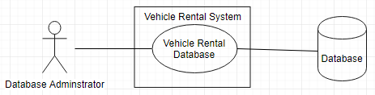

* + 1. Upload Vehicle Data

|  |  |
| --- | --- |
| Use Case Name | Upload vehicle Data |
| Scope | Under Design |
| Level | Sub-function |
| Primary Actor | Administrator |
| Stakeholders and Interest | Professor and Administrator |
| Preconditions | Database is created, Application is up and running |
| Success Guarantee | Vehicle details are uploaded and saved to database |
| Main Success Scenario | 1. Admin visits the website 2. Select file with vehicle details to upload data in database |
| Extensions | Scenario 1:  1a) Refresh the website  Scenario 2:  2a) File format Not supported, system displays message of accepted file format  Scenario 3:  2a) File unreadable/Corrupt, system ask Customer to re-upload a valid file. |
| Special Requirements | Response time should be within seconds |
| Technology and Data Variations List | Browser, Database |
| Frequency of Occurrence | Highly Used |
| Miscellaneous | NA |

Use Case Diagram: Upload vehicle Data

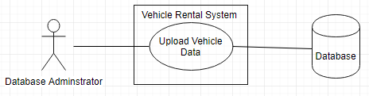

* + 1. Search a Vehicle

|  |  |
| --- | --- |
| Use Case Name | Search a Vehicle |
| Scope | Under Design |
| Level | Sub-function |
| Primary Actor | Customer |
| Stakeholders and Interest | Professor and Customer |
| Preconditions | Application should be up and running |
| Success Guarantee | List of vehicle should be available to select |
| Main Success Scenario | 1. Customer visits the website 2. Customer Enters “Pick-up Date”, “Drop Off Date” and Location 3. Customers searches the vehicle |
| Extensions | Scenario 1:  1a) Customer refresh Page  Scenario 2:  2a) Customer can enter frequently travelled destination such as Disneyland.  Scenario 3:  2a) Location entered using voice recognition  Scenario 4:  2a) Location entered using Customer’s location. |
| Special Requirements | Response time should be within seconds |
| Technology and Data Variations List | Browser, Database |
| Frequency of Occurrence | 4 hits per second |
| Miscellaneous | NA |

Use Case Diagram: Search a Vehicle

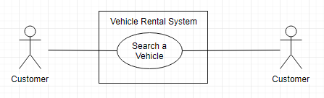

* + 1. View Vehicle Details

|  |  |
| --- | --- |
| Use Case Name | View Vehicle Details |
| Scope | Under Design |
| Level | Sub-function |
| Primary Actor | Customer |
| Stakeholders and Interest | Professor and Customer |
| Preconditions | Customer Entered Search Criteria |
| Success Guarantee | List of vehicle displayed should have details of Make and Model, Image, Price and Mileage |
| Main Success Scenario | 1. Customers searches a vehicle 2. Details of vehicles Make and Model, Image, Price and Mileage is displayed |
| Extensions | Scenario 1:  2a) Customer refresh Page |
| Special Requirements | Response time should be within seconds |
| Technology and Data Variations List | Browser, Database |
| Frequency of Occurrence | 4 hits per second |
| Miscellaneous | NA |

Use Case Diagram: View Vehicle Details

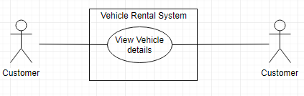

* + 1. Search on Passenger Capacity

|  |  |
| --- | --- |
| Use Case Name | Search on Passenger Capacity |
| Scope | Under Design |
| Level | Sub-function |
| Primary Actor | Customer |
| Stakeholders and Interest | Professor and Customer |
| Preconditions | Application should be up and running |
| Success Guarantee | List of vehicle displayed with defined passenger capacity |
| Main Success Scenario | 1. Customer visits the website 2. Customer Enters “Pick-up Date”, “Drop Date”, Location 3. Customer Enter Passenger Capacity 4. Customers searches the vehicle |
| Extensions | Scenario 1:  2a) Refer Use Case 3  Scenario 2:  3a) Customer re-enter Passenger Capacity |
| Special Requirements | Response time should be within seconds |
| Technology and Data Variations List | Browser, Database |
| Frequency of Occurrence | 4 hits per second |
| Miscellaneous | NA |

Use Case Diagram: Search on Passenger Capacity

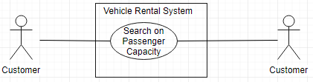

* + 1. Search on Price Range

|  |  |
| --- | --- |
| Use Case Name | Search on Price Range |
| Scope | Under Design |
| Level | Sub-function |
| Primary Actor | Customer |
| Stakeholders and Interest | Professor and Customer |
| Preconditions | Application should be up and running |
| Success Guarantee | List of vehicle displayed within the price range |
| Main Success Scenario | 1. Customer visits the website 2. Customer Enters “Pick-up Date”, “Drop Date”, Location 3. Customer Enters Price Range 4. Customers searches the vehicle |
| Extensions | Scenario 1:  2a) Refer Use Case 3  Scenario 2:  3a) Customer re-enter Price Range |
| Special Requirements | Response time should be within seconds |
| Technology and Data Variations List | Browser, Database |
| Frequency of Occurrence | 4 hits per second |
| Miscellaneous | NA |

Use Case diagram: Search on Price Range

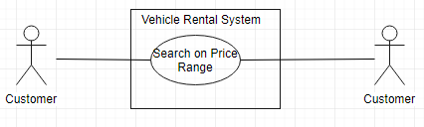

* + 1. Search on Vehicle Type

|  |  |
| --- | --- |
| Use Case Name | Search on Vehicle Type |
| Scope | Under Design |
| Level | Sub-function |
| Primary Actor | Customer |
| Stakeholders and Interest | Professor and Customer |
| Preconditions | Application should be up and running |
| Success Guarantee | List of vehicle displayed for given vehicle type |
| Main Success Scenario | 1. Customer visits the website 2. Customer Enters “Pick-up Date”, “Drop Date”, Location 3. Customer Enters Vehicle Type 4. Customers searches the vehicle |
| Extensions | Scenario 1:  2a) Refer Use Case 3  Scenario 2:  3a) Customer re-enter Vehicle Type |
| Special Requirements | Response time should be within seconds |
| Technology and Data Variations List | Browser, Database |
| Frequency of Occurrence | 4 hits per second |
| Miscellaneous | NA |

Use Case Diagram: Vehicle Type

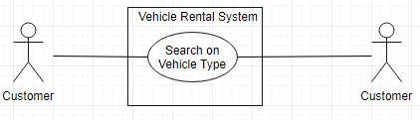

* + 1. Search on Transmission Mode

|  |  |
| --- | --- |
| Use Case Name | Search on Transmission Mode |
| Scope | Under Design |
| Level | Sub-function |
| Primary Actor | Customer |
| Stakeholders and Interest | Professor and Customer |
| Preconditions | Application should be up and running |
| Success Guarantee | List of vehicle displayed for given transmission mode |
| Main Success Scenario | 1. Customer visits the website 2. Customer Enters “Pick-up Date”, “Drop Date”, Location 3. Customer Enters Transmission Mode 4. Customers searches the vehicle |
| Extensions | Scenario 1:  2a) Refer Use Case 3  Scenario 2:  3a) Customer re-enter Transmission Mode |
| Special Requirements | Response time should be within seconds |
| Technology and Data Variations List | Browser, Database |
| Frequency of Occurrence | 4 hits per second |
| Miscellaneous | NA |

Use Case Diagram: Search on Transmission Mode

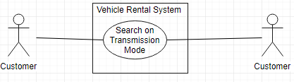

* + 1. Register an Account

|  |  |
| --- | --- |
| Use Case Name | Register an Account |
| Scope | Under Design |
| Level | Sub-function |
| Primary Actor | Customer |
| Stakeholders and Interest | Professor and Customer |
| Preconditions | Application should be up and running |
| Success Guarantee | Registered an Account |
| Main Success Scenario | 1. Customer enters username, password, First Name, Last Name, Email and DOB (Mandatory) 2. System stores Customer information and creates an account |
| Extensions | Scenario 1:  1a)Username already exists and system displays available username  1b) Customer enters new or choose from available username  Scenario 2:  1a) All fields not entered, system displays message to enter all fields  1b) Customer enters all fields value  Scenario 3:  1a) Incorrect format entered for given fields e.g. email in wrong format, system displays message to enter in correct format  1b) Customer enters correct details  Scenario 4:  2a) System unable to store details, message is displayed to re-enter details  2b) Customer re-enters details |
| Special Requirements | Response time should be within seconds |
| Technology and Data Variations List | Browser, Database |
| Frequency of Occurrence | Could be nearly continuous |
| Miscellaneous | NA |

Use Case Diagram: Register an Account

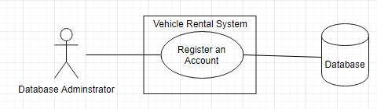

* + 1. Login to Account

|  |  |
| --- | --- |
| Use Case Name | Login to Account |
| Scope | Under Design |
| Level | Sub-function |
| Primary Actor | Customer |
| Stakeholders and Interest | Professor and Customer |
| Preconditions | Customer should be registered |
| Success Guarantee | Logged in to application |
| Main Success Scenario | 1. Customer enters valid username and password 2. Customer logged in to account |
| Extensions | Scenario 1:  1a)Username or password invalid, systems displays message and displays screen to re-enter details  1b) Customer enters valid username and password  Scenario 2:  1a) Username, password not entered, system displays message to enter username and password  1b) Customer enters username and password |
| Special Requirements | Response time should be within seconds |
| Technology and Data Variations List | Browser, Database |
| Frequency of Occurrence | Could be nearly continuous |
| Miscellaneous | NA |

Use Case Diagram: Login to account

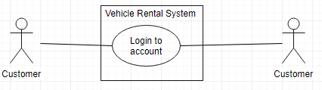

* + 1. View the bookings

|  |  |
| --- | --- |
| Use Case Name | View the bookings |
| Scope | Under Design |
| Level | Sub-function |
| Primary Actor | Customer |
| Stakeholders and Interest | Professor and Customer |
| Preconditions | Customer logged in to the account |
| Success Guarantee | View all the bookings made |
| Main Success Scenario | 1. Customer selects view Bookings 2. All bookings made by the customer is displayed. |
| Extensions | Scenario 1:  2a) Customer refresh the page if bookings not displayed |
| Special Requirements | Response time should be within seconds |
| Technology and Data Variations List | Browser, Database |
| Frequency of Occurrence | Could be nearly continuous |
| Miscellaneous | NA |

Use Case Diagram: View the bookings

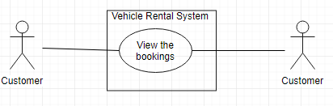

* + 1. Filter on Price Range

|  |  |
| --- | --- |
| Use Case Name | Filter on Price Range |
| Scope | Under Design |
| Level | Sub-function |
| Primary Actor | Customer |
| Stakeholders and Interest | Professor and Customer |
| Preconditions | Customer searched vehicle and list of all the vehicles is displayed |
| Success Guarantee | List of all the vehicles displayed is sorted based on Price |
| Main Success Scenario | 1. Customer clicks on Price Range filter and list is sorted with Price |
| Extensions | Scenario 1:  1a) Customer re-click Price filter if list is not sorted. |
| Special Requirements | Response time should be within seconds |
| Technology and Data Variations List | Browser, Database |
| Frequency of Occurrence | Could be nearly continuous |
| Miscellaneous | NA |

Use Case Diagram: Filter on Price Range

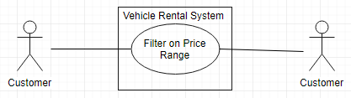

* + 1. Billing for Vehicle Booking

|  |  |
| --- | --- |
| Use Case Name | Billing for Vehicle Booking |
| Scope | Under Design |
| Level | Sub-function |
| Primary Actor | Customer |
| Stakeholders and Interest | Professor and Customer |
| Preconditions | Customer selects the vehicle |
| Success Guarantee | Customer completed the payment and booked the vehicle |
| Main Success Scenario | 1. Customer select vehicle to be rented and go to billing 2. Customer selects Billing method as Cash. 3. Pays the amount and book the vehicle |
| Extensions | Scenario 1:  2a) Billing method selected is Cards  2b) Complete payment authorization for card  Scenario 2:  Scenario 1:  2a) Billing method selected is Direct Deposit  2b) Enter Direct Deposit details and complete payment  Scenario 3:  2a) Billing method selected is Android/Apple Pay  2b) Complete Payment details  Scenario 4:  2a) Billing method selected is Cashier’s Check  2b) Upload Cashier’s Check and complete the billing  Scenario 5:  2a) Use the collected reward points and complete payment |
| Special Requirements | Response time should be within seconds |
| Technology and Data Variations List | Browser, Database |
| Frequency of Occurrence | Could be nearly continuous |
| Miscellaneous | NA |

Use Case Diagram: Billing for vehicle booking

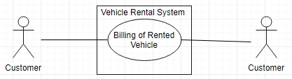

* + 1. Search vehicle with voice recognition

|  |  |
| --- | --- |
| Use Case Name | Search vehicle with voice recognition |
| Scope | Under Design |
| Level | Sub function |
| Primary Actor | Customer |
| Stakeholders and Interest | Professor and Customer |
| Preconditions | Application should be up and running |
| Success Guarantee | List of vehicles should be available to select |
| Main Success Scenario | 1. Customer visits the website 2. Customer selects voice recognition option 3. Customer speaks to search a vehicle |
| Extensions | Scenario 1:  1a) Customer refresh Page  Scenario 2:  3a)Customer has to type to search for a vehicle |
| Special Requirements | Response time should be within seconds |
| Technology and Data Variations List | Browser, Database |
| Frequency of Occurrence | Could be nearly continuous |
| Miscellaneous | N/A |

Use Case Diagram: Search vehicle with voice recognition

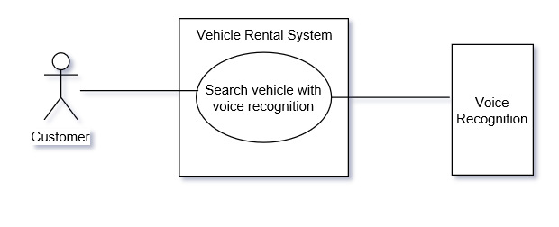

## 3.2 CLASS DIAGRAM

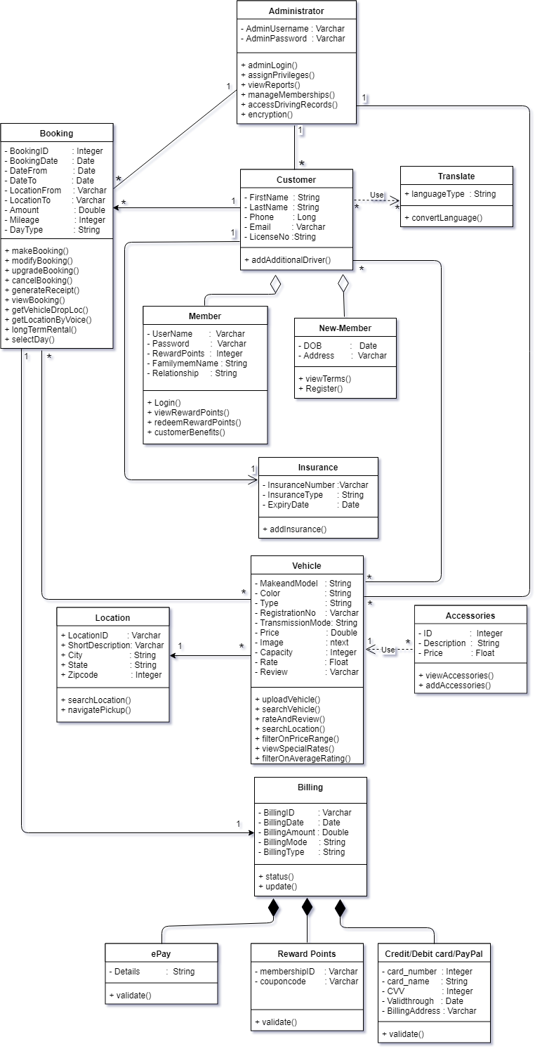

## 3.3 INTERACTION DIAGRAMS

### 3.3.1 Sequence diagrams

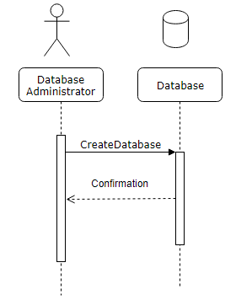

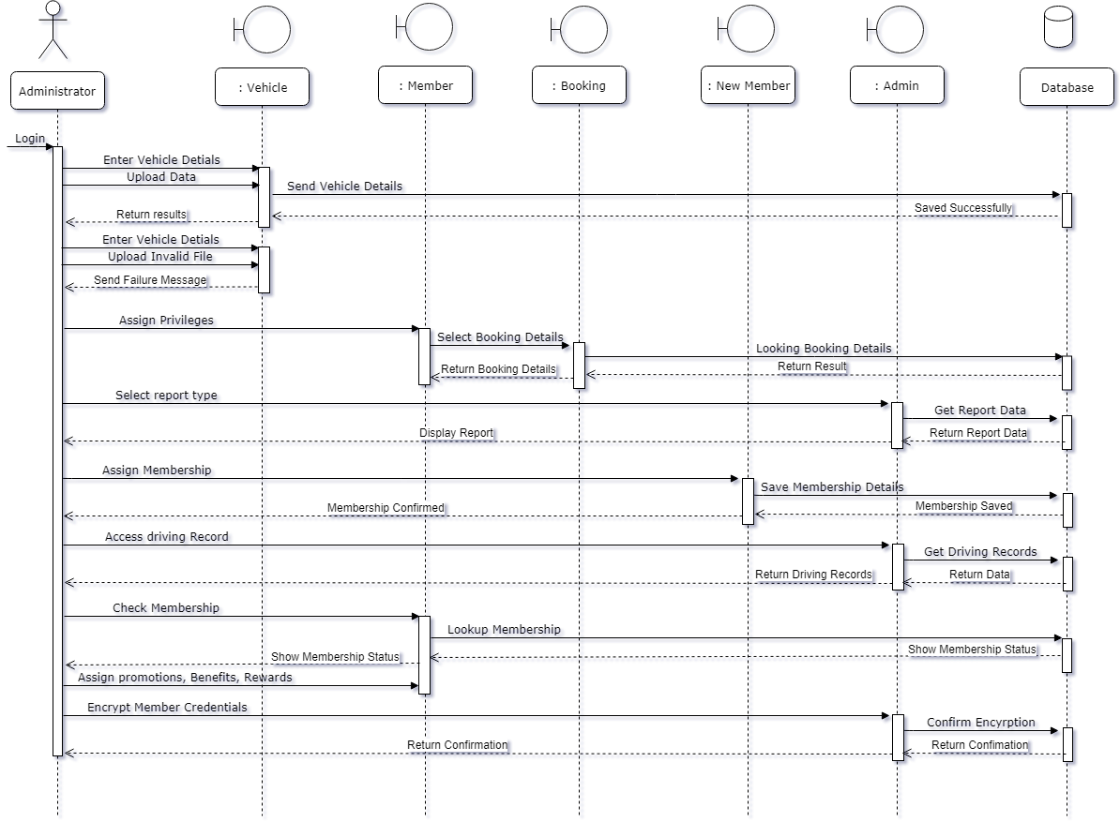

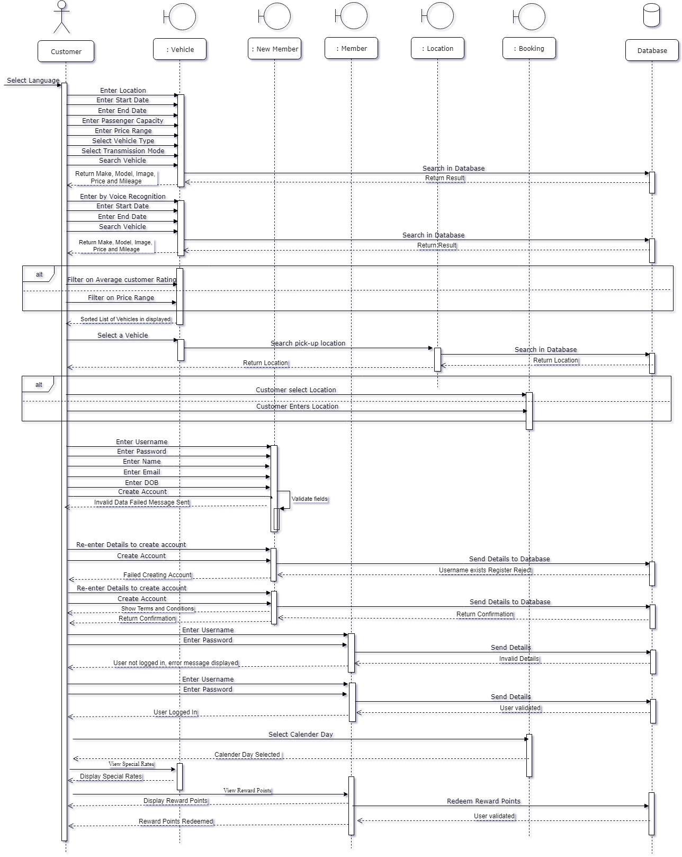

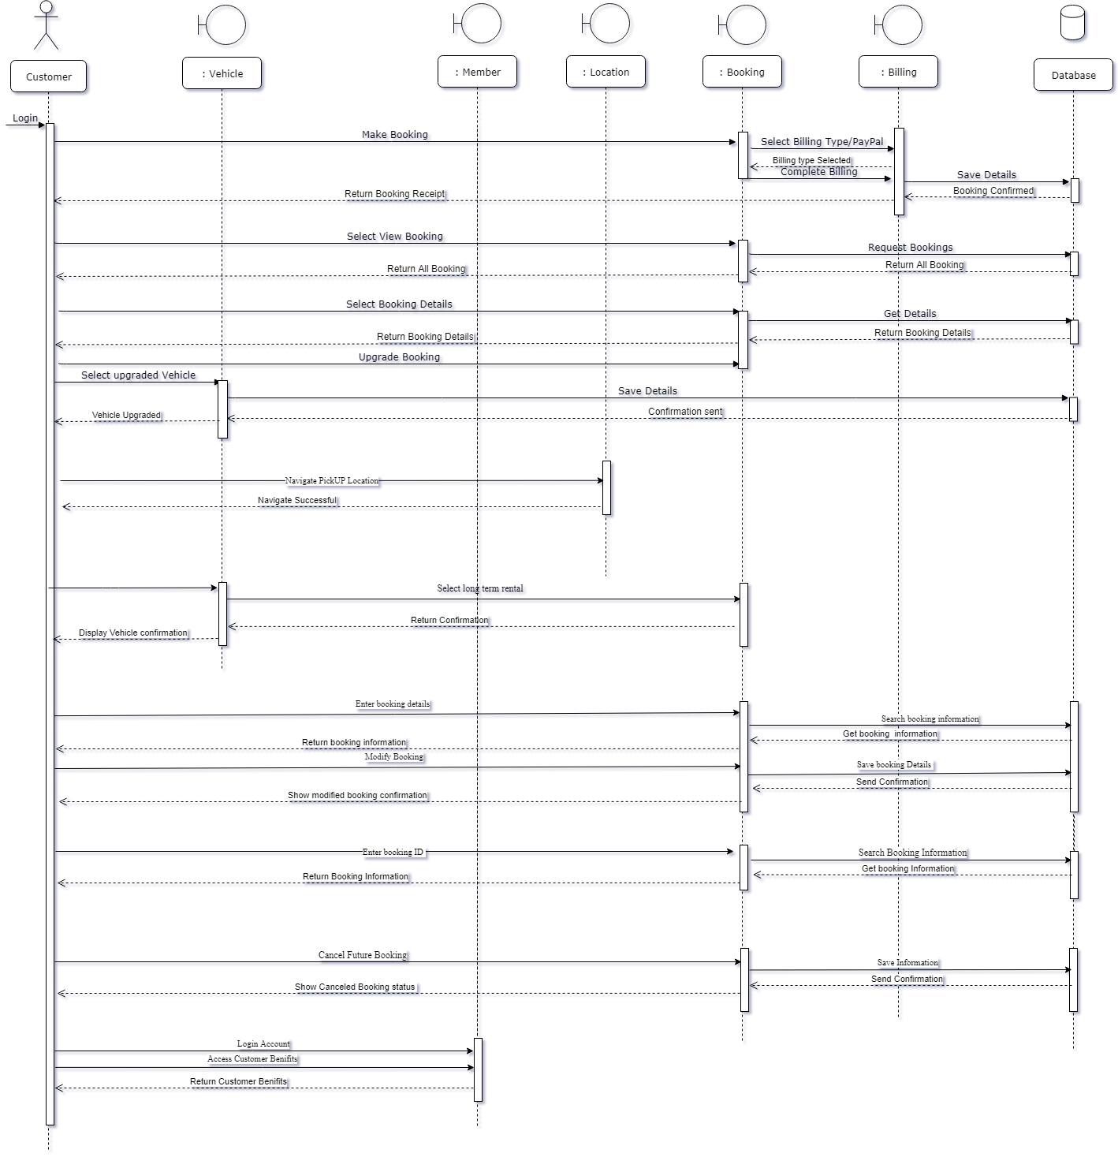

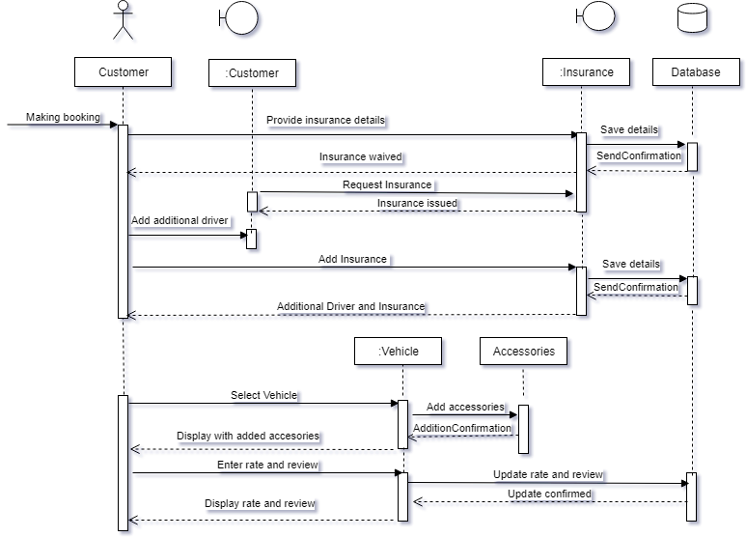

### 3.3.2 Communication Diagrams

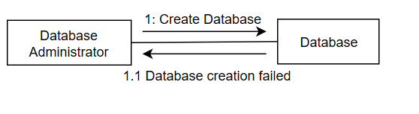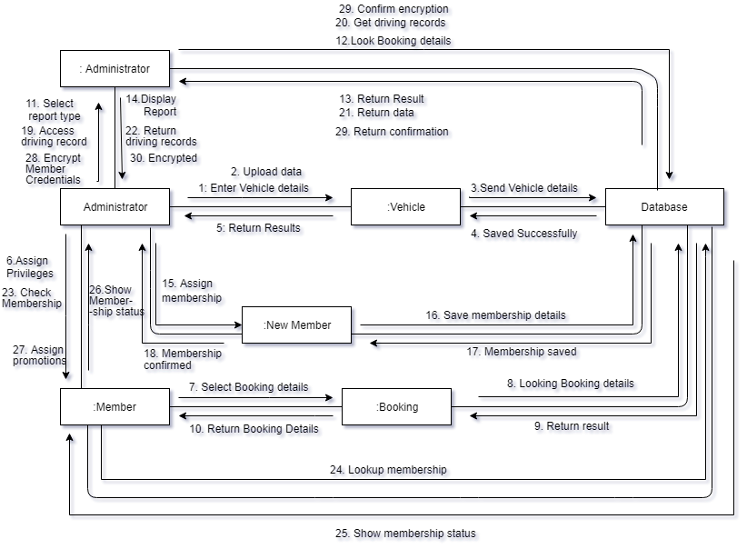

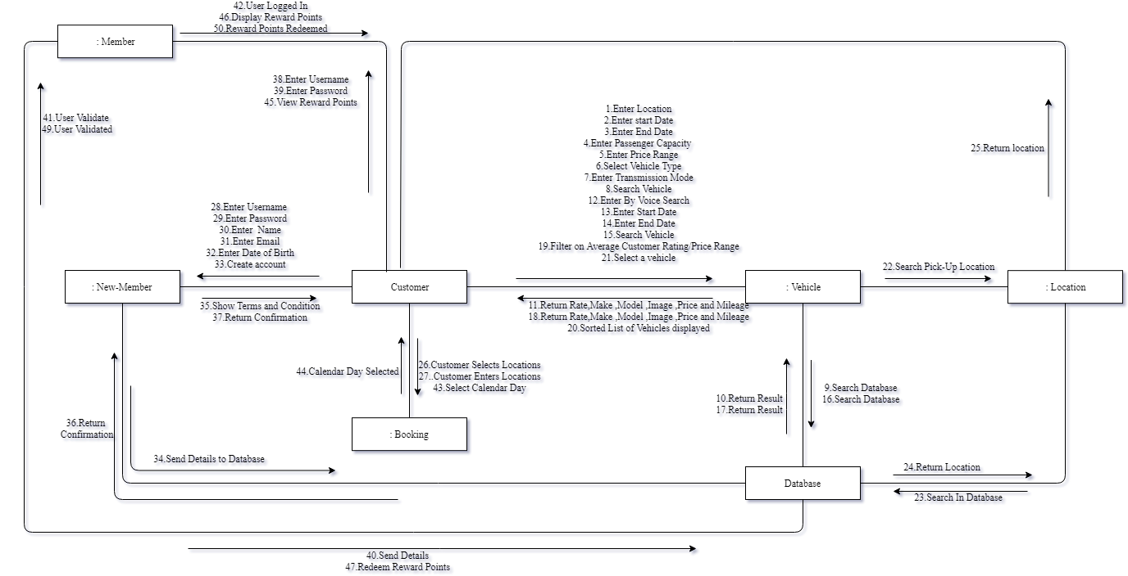

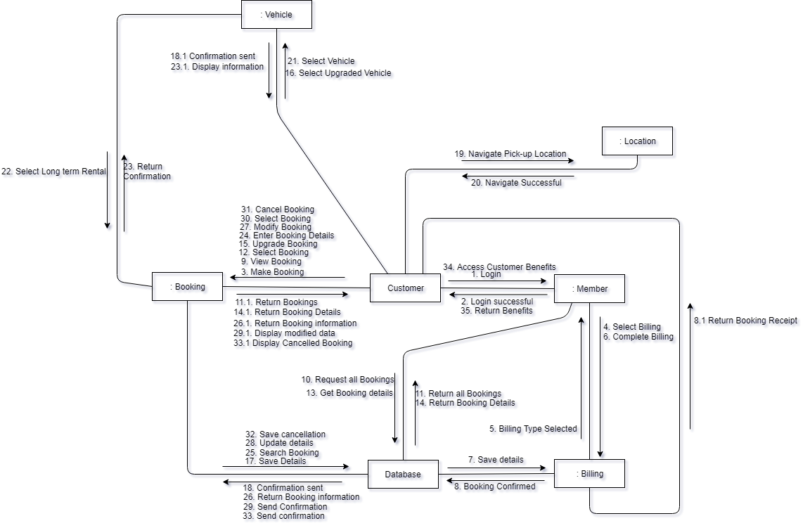

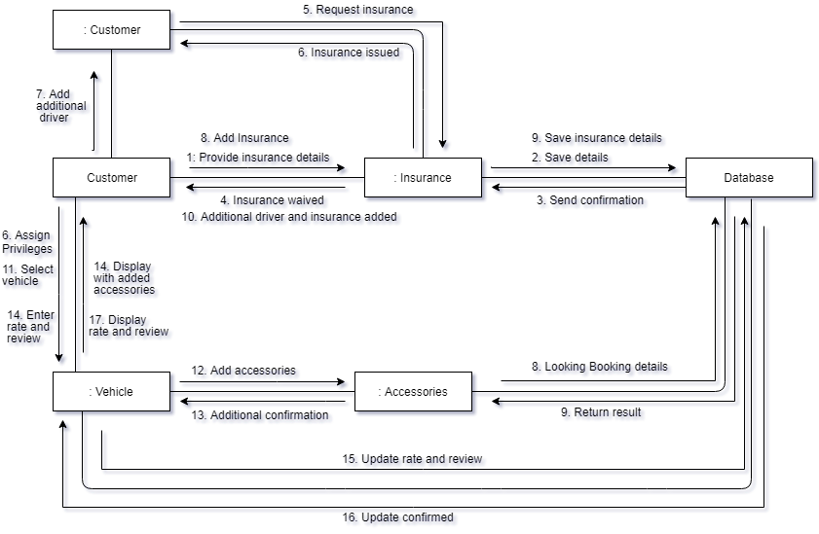

## 3.4 STATE DIAGRAM

#### 3.4.1 Admin

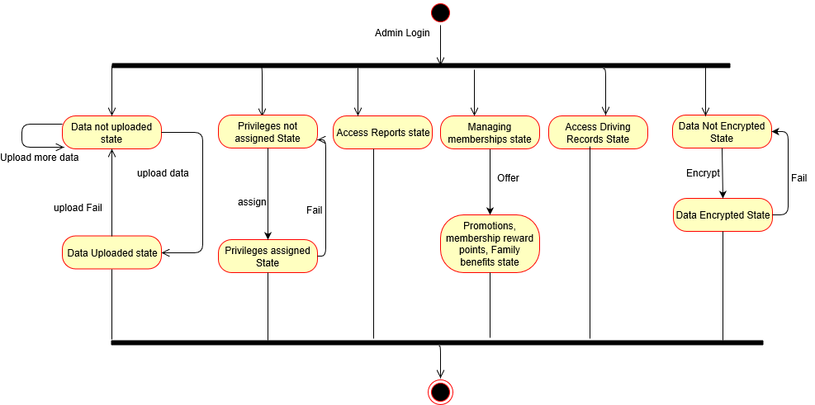

#### 3.4.2 Vehicle

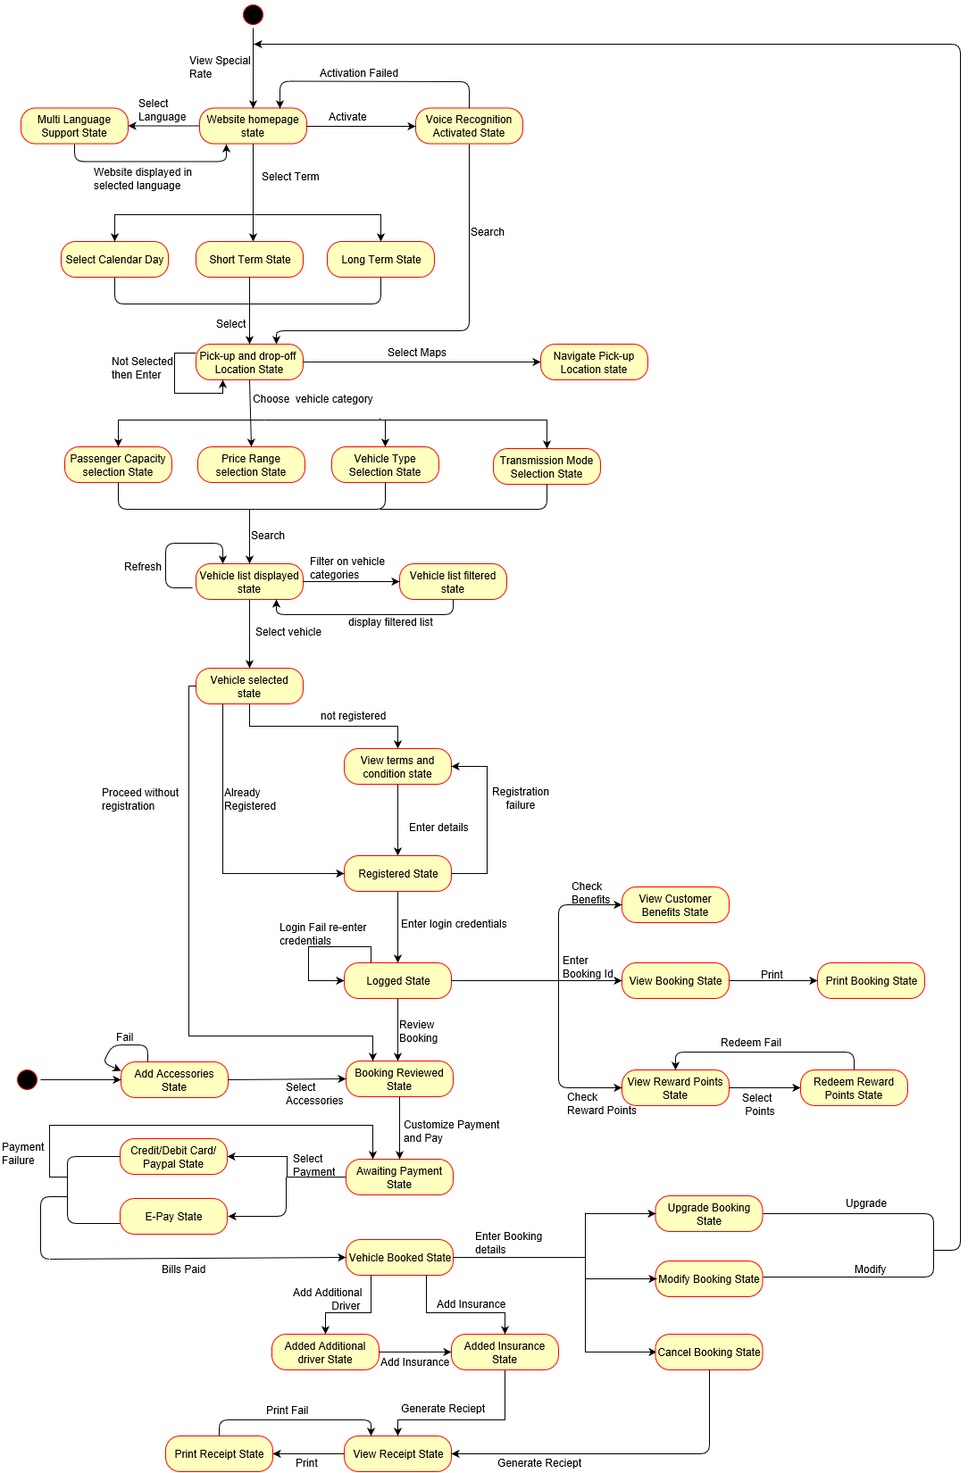

#### Rate and Review

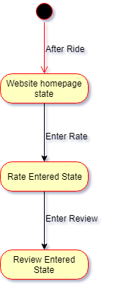

## 3.5 SERVICE ORIENTED ARCHITECTURE

#### 3.5.1 Authentication service

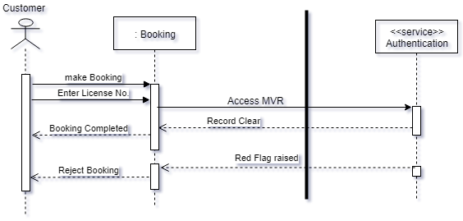

#### 3.5.2 Translate service and vehicle service

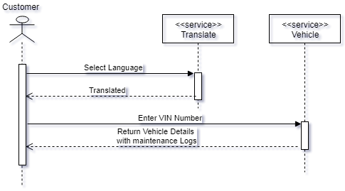

## 3.6 GRASP

#### 3.6.1 Polymorphism Pattern for Billing

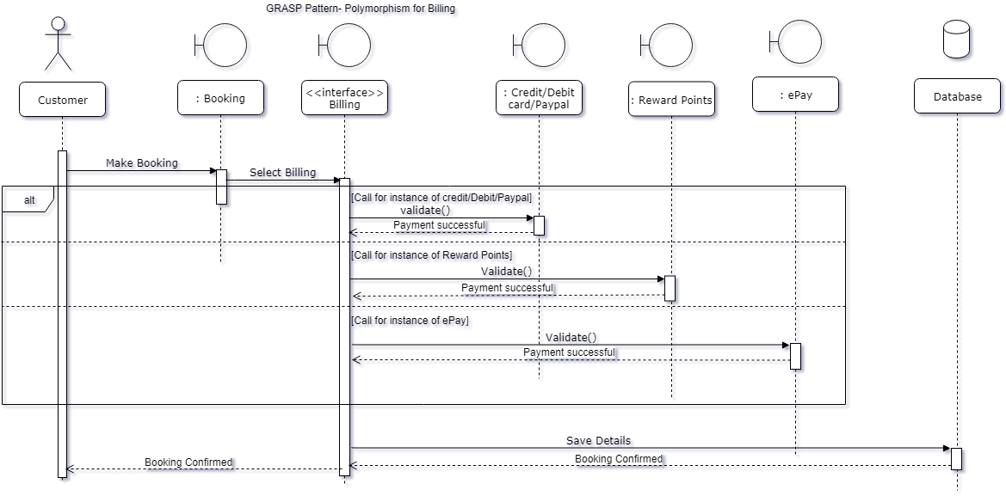

#### Creator Pattern for Vehicle and Accessories

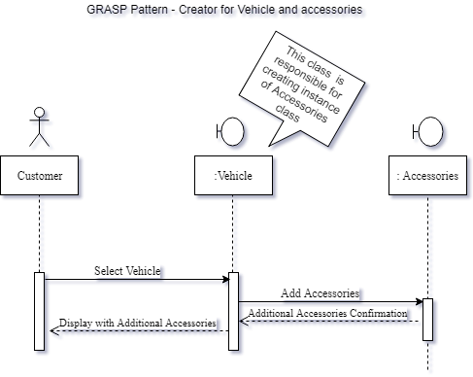

## 3.7 GoF Patterns

Factory Pattern

3.7.1 Vehicle Type (Sequence Diagram)

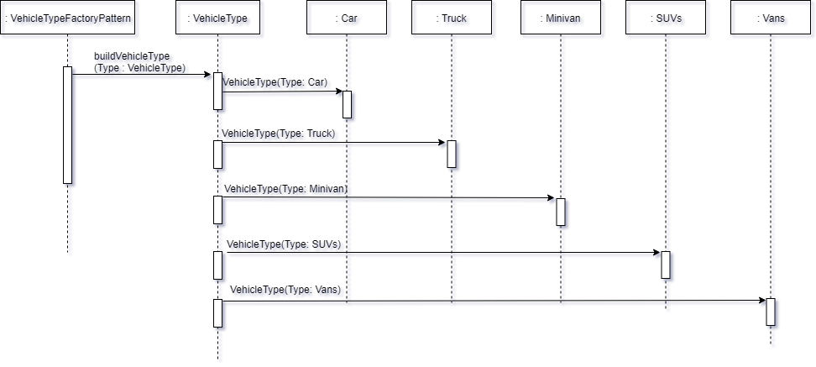

3.7.2 Vehicle Type (Class Diagram)

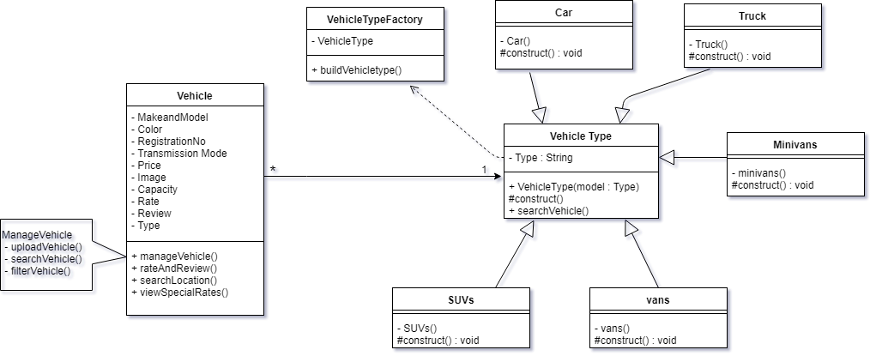

3.7.3 Transmission Mode(Class Diagram)

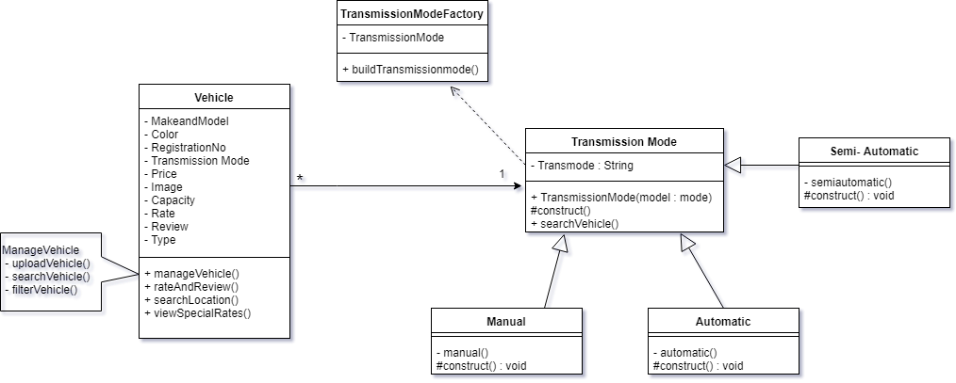

* + 1. Transmission Mode(Sequence Diagram)

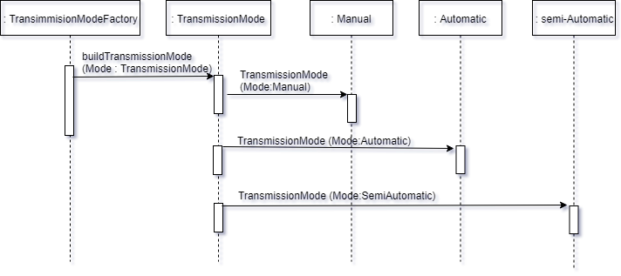

# 4. USER INTERFACE AND FUNCTIONS

* 1. User Interfaces

4.1.1 Main (Add vehicle)

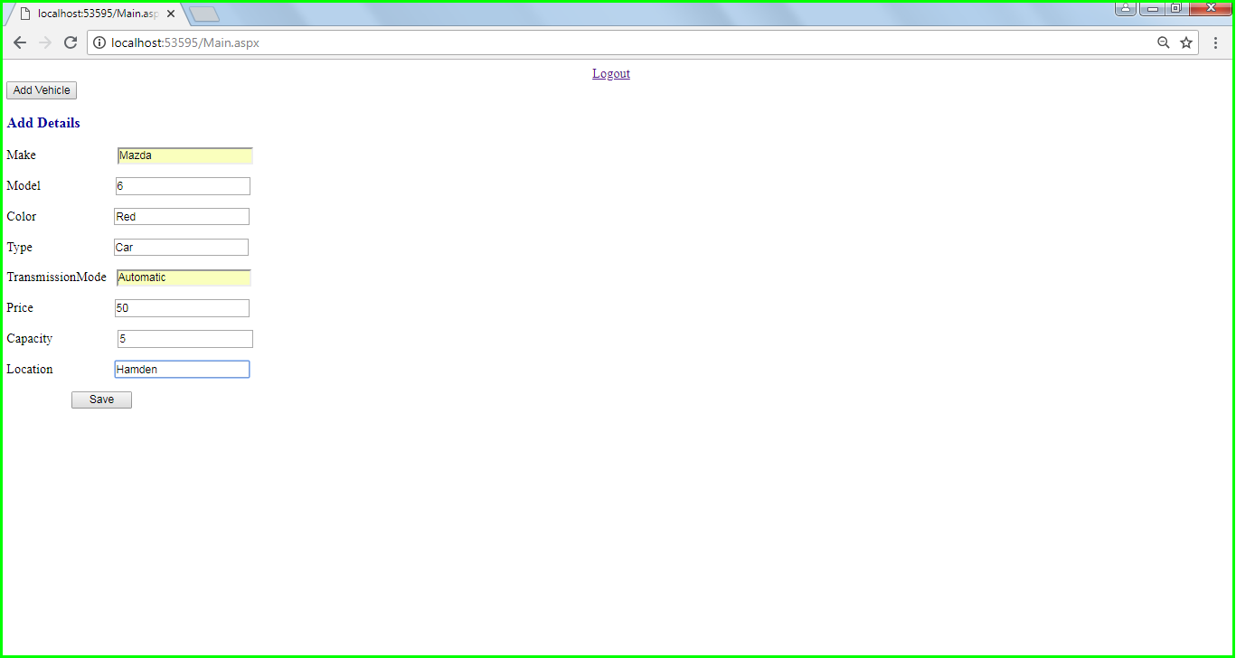

* After Admin logs in to the system, option to add vehicle is displayed.

On selecting add vehicle and providing details of the new vehicle, admin successfully adds vehicle to rent list.

4.1.2 Home 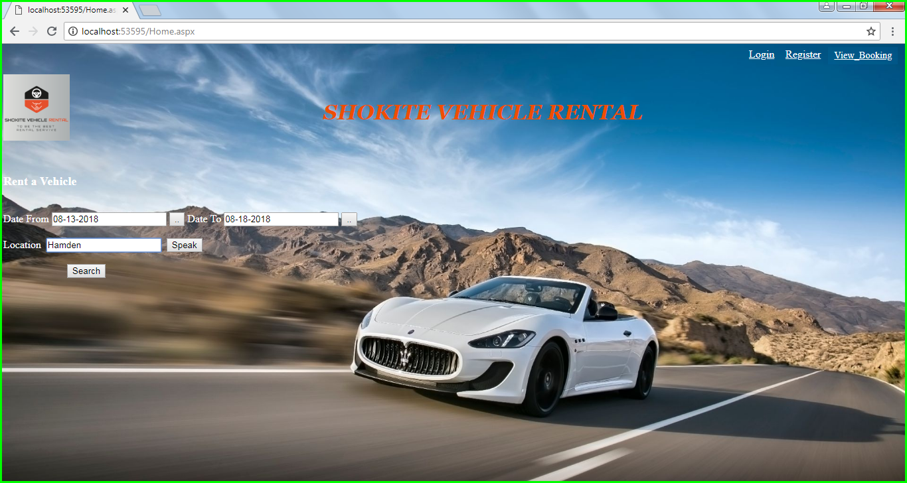

* User selects ‘date from’ and ‘date to’
* User enters ‘location’ or uses ‘voice recognition’ to speak location
* User searches Vehicle
  + 1. Vehicle

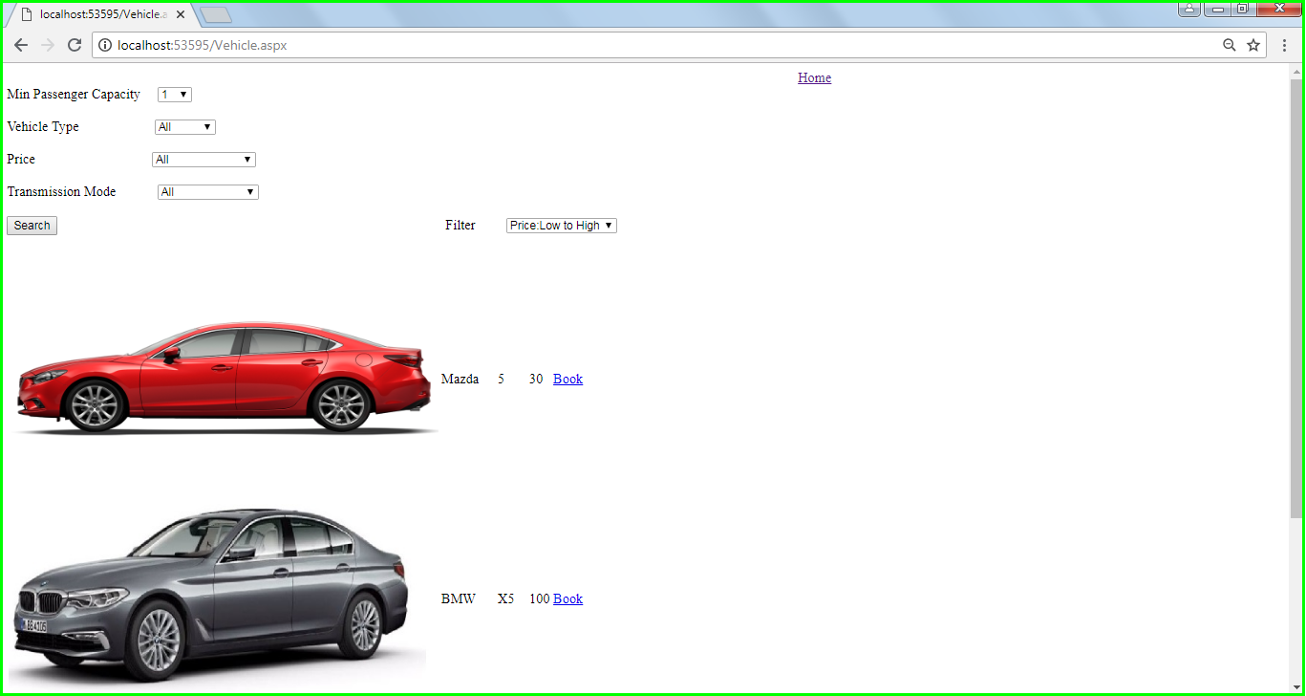

* User can choose from dropdown list for selecting passenger capacity, vehicle type, price and transmission mode.
* User can then view list of all the vehicles avaliable to book.
  + 1. Booking

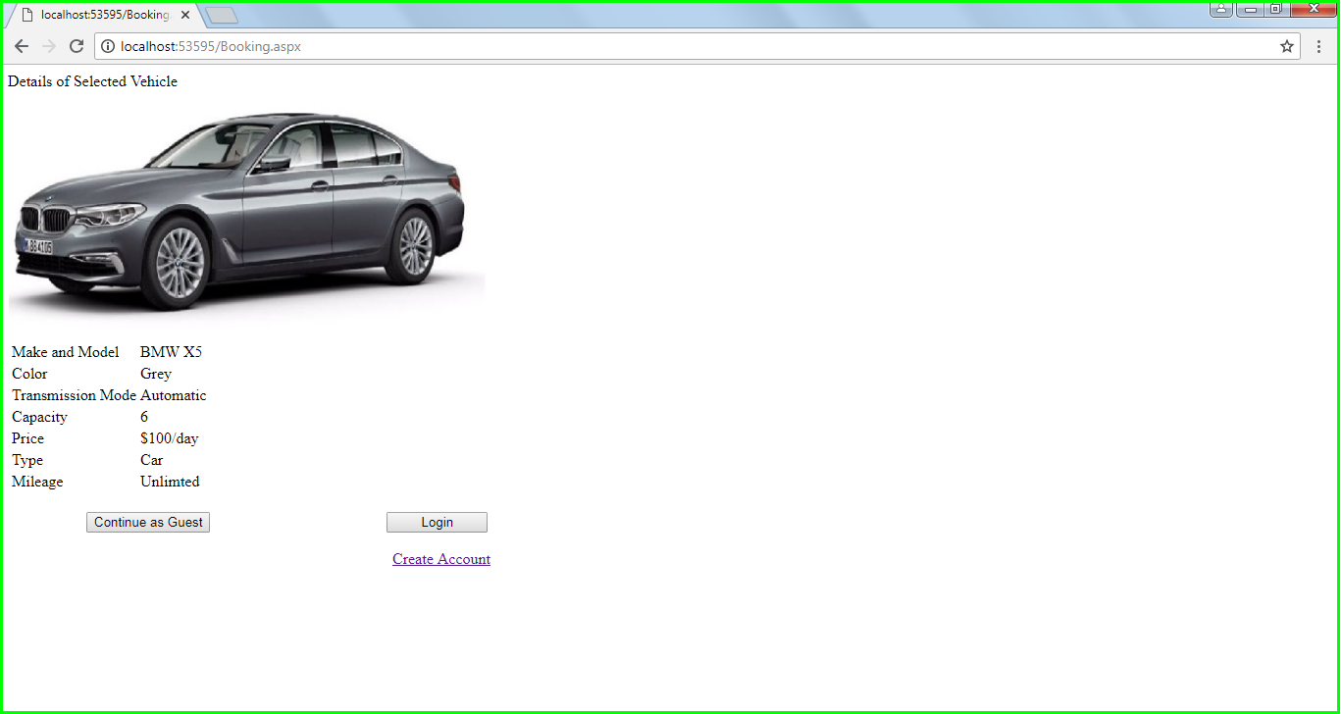

* User can view selected vehicle specifics and information
* User now can continue as a guest or can create an account to proceed booking.
* User can also login to book a vehicle
  + 1. Register

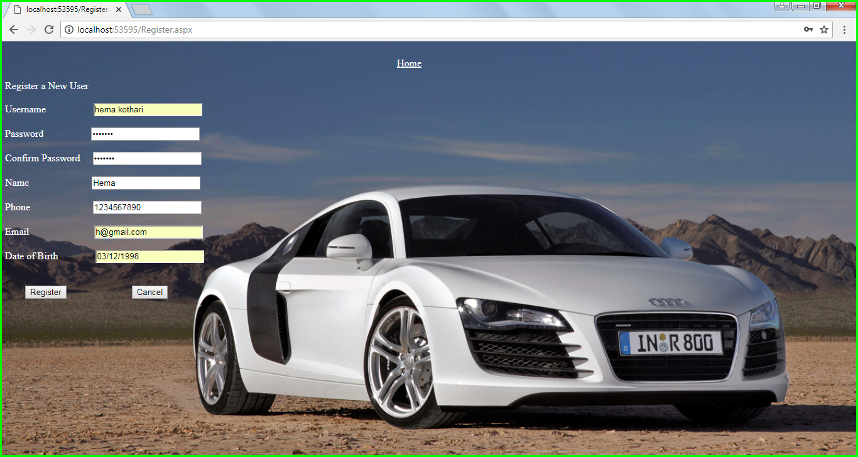

* User can register by entering all their details.
* The User will be able to register successfully.
  + 1. Admin/User Login

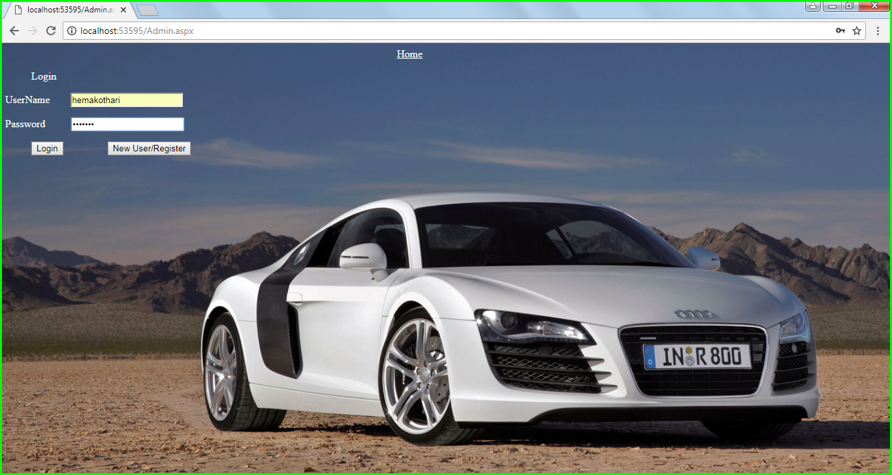

* This page is for admin and/or user login .
* Admin/ user has to enter username and password
* Depending on the role, for admin and user will be able to access different screens.
* User can use ‘New User/Register’ option to register a new account.
  + 1. Review (Continue as Guest option)

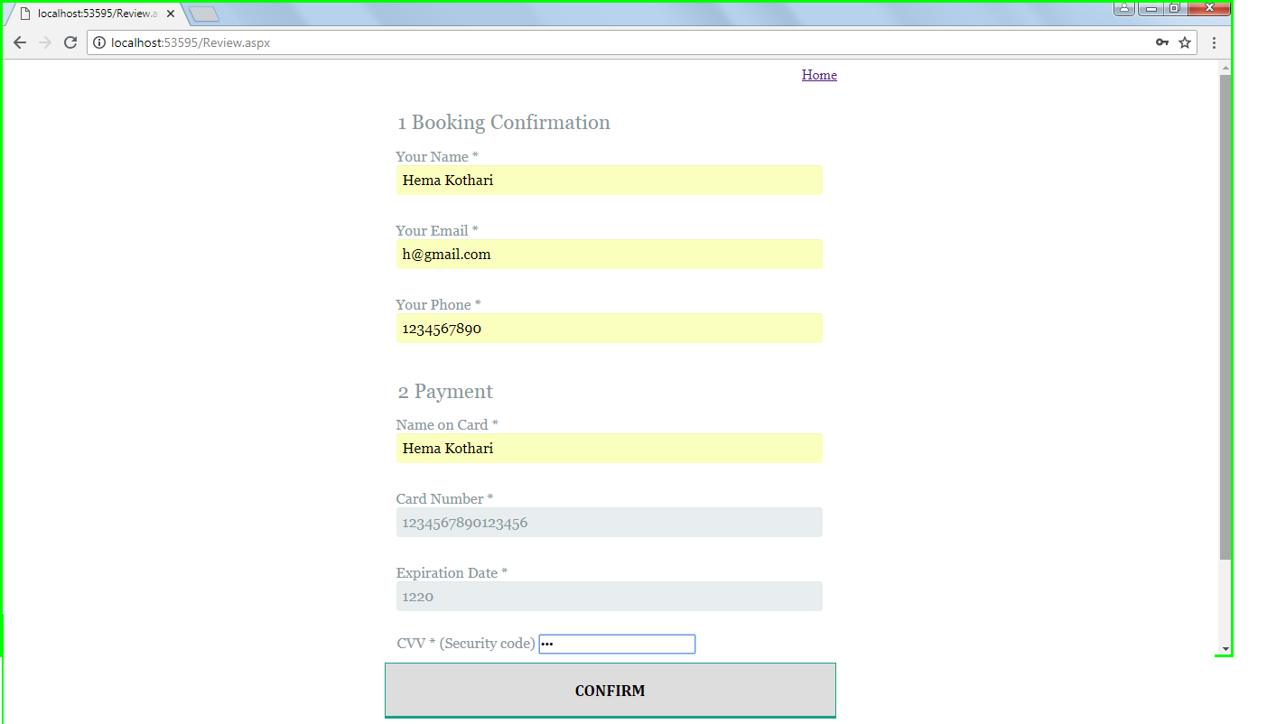

* User when provided with all the details like name,email, phone number and payment details should be able to book the vehicle.
  + 1. Payment (Continue after Logging in)

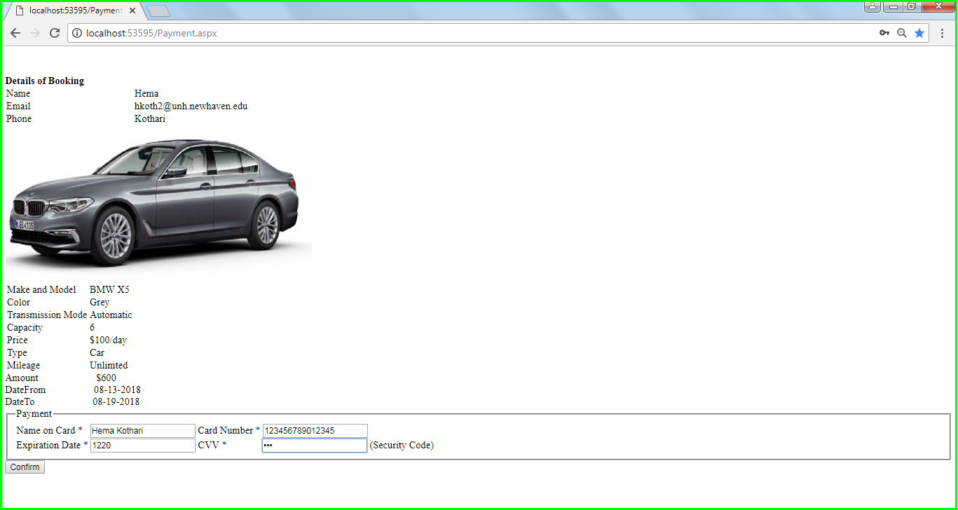

* After the user is logged in and slected a vehicle, user should be able to view the details and enter payment information (Name on card, card number, Expiration date,Cvv) to be able to confirm booking.
  + 1. Confirmation

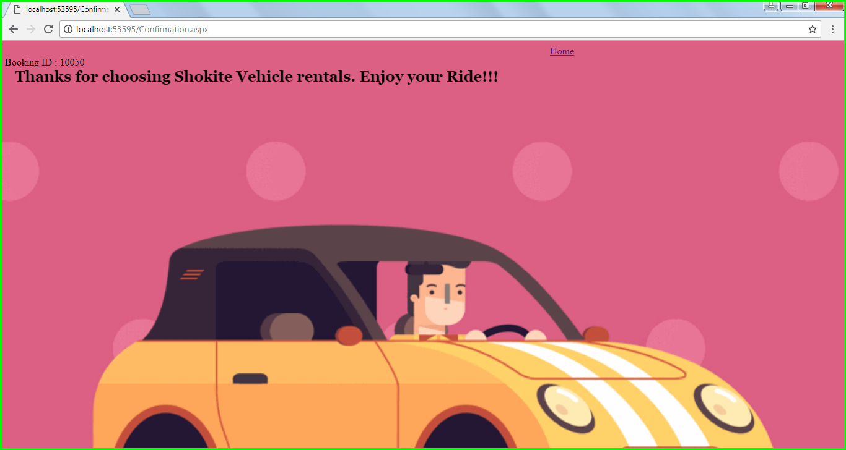

* User has successfully booked a vehicle.
* User is provided with a unique Booking ID.
  + 1. View Booking

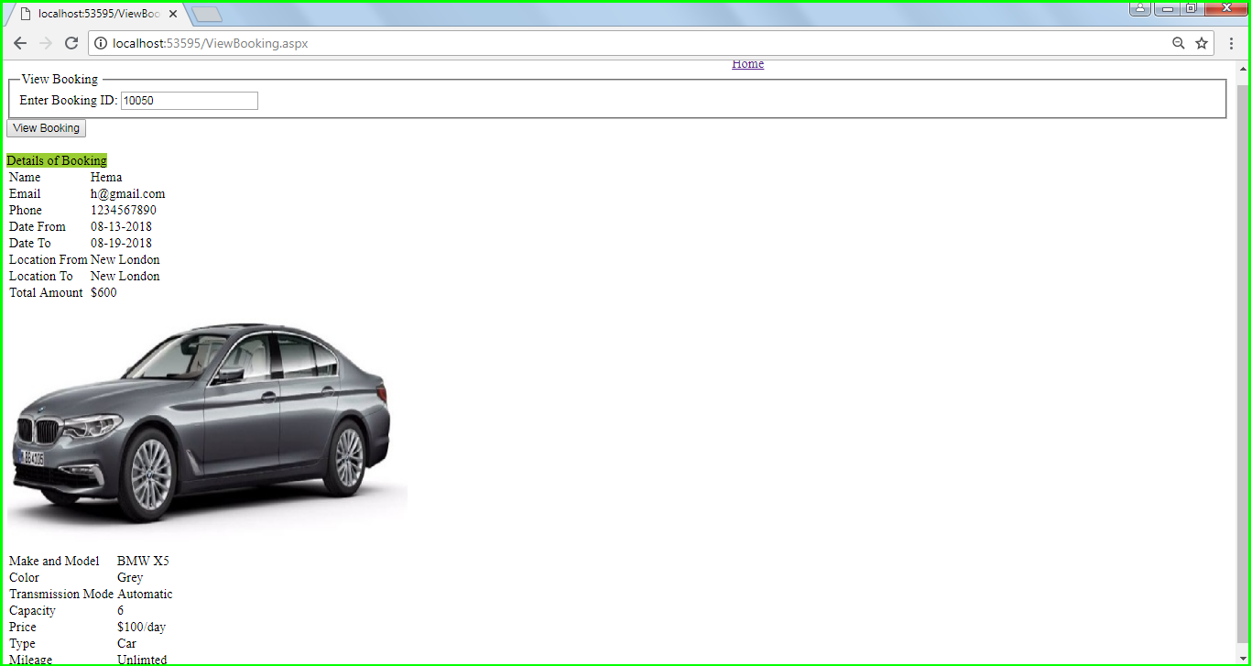

* User can enter Booking ID
* User can view the complete booking details.

# USER INTERFACE

1. Enter URL to access the application: http://localhost:53595/Home.aspx
2. Application Home Page is displayed.
3. In the application we can perform below mentioned functions.

Steps for ‘Register’

1. On the Home Page select ‘Register’
2. Enter Username, Password, Confirm Password, Name, Phone, Email, Date of Birth.
3. Click Register
4. If User does not wish to proceed with Registration, then click on ‘Cancel’ which will display Home Page

Steps to ‘Log-in’ into the System

1. After Registration User can Login into the system
2. On the Home Page select ‘Login’
3. Enter Valid Username and Password
4. User is logged in to the system.
5. If User does not enter/enters incorrect details then an error message will be displayed.

Steps for ‘Searching Vehicle’

1. On the Home Page enter ‘Date From’, ‘Date To’ and ‘Location’ and search for vehicle.
2. User can Login and from there he can also search the vehicle following the steps as above.
3. User can utilize ‘Voice Recognition’ option for location and can search vehicle.

For Voice Recognition,

1. select ‘Speak’ button
2. speak the Location
3. Application will accept the location and display list of all vehicles available at that location.
4. Once details are entered list of all the available vehicles at selected location will be displayed.
5. User can search vehicle based on Min Passenger Capacity, Vehicle Type (Car, Vans, SUVs, Truck, Minivans), Price Range and Transmission Mode (Automatic, Manual and Semi-Automatic)
6. User can also filter the data using Price Range of Low to High and High to Low.
7. If any of Date From, Date To and Location is not entered then Error Message will be displayed.

Steps for ‘Booking Vehicle’

1. User will select vehicle they wish to Book from the list of available vehicles.
2. Once vehicle is selected, complete details of the vehicle are displayed.
3. User can now Book Vehicle by
4. Login (After Registration)

4. Enter the Username and Password and Login

5. Review Vehicle Details

6. Complete the Payment

7. Vehicle Booking Id is provided to User for future reference

1. Continue as Guest

4. Enter Name, Email and Phone

5. Complete Payment

6. Vehicle Booking Id is provided to User for future reference

Steps to View ‘Booked Vehicle’

1. After Vehicle is Booked, Booking Id is provided to the User
2. User can view his bookings with the Booking ID by selecting ‘View Booking’ option on the Home Page.
3. Booking Details will be displayed
4. If incorrect Booking Id is entered, an error message will be displayed.

# 6. PROGRAM

## 6.1 Data files

6.1.1 Vehicle Table

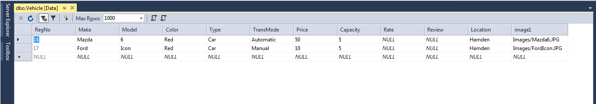

6.1.2 Customer Table

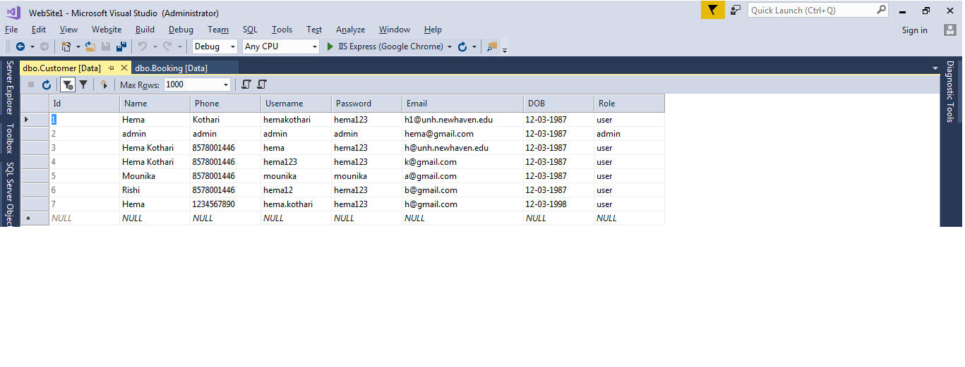

6.1.3 Booking Table

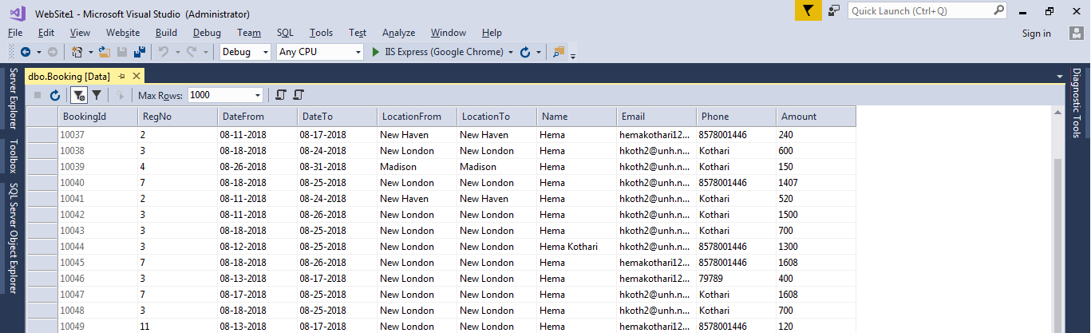

## 6.2 Testing Documentation

### 6.2.1 Testing Plan or Unit, Systems and Acceptance Testing

|  |  |
| --- | --- |
| **Test Case 1** | |
| **Test Case Name:** | On Login Screen, Username/ Password not entered |
| **Description:** | If Username/ Password is not entered, will show error message. |
| **Output:** | Display validation Controller message in browser “Enter Username”  Display validation Controller message in browser “Enter Password” |

* 1. **Enter Username**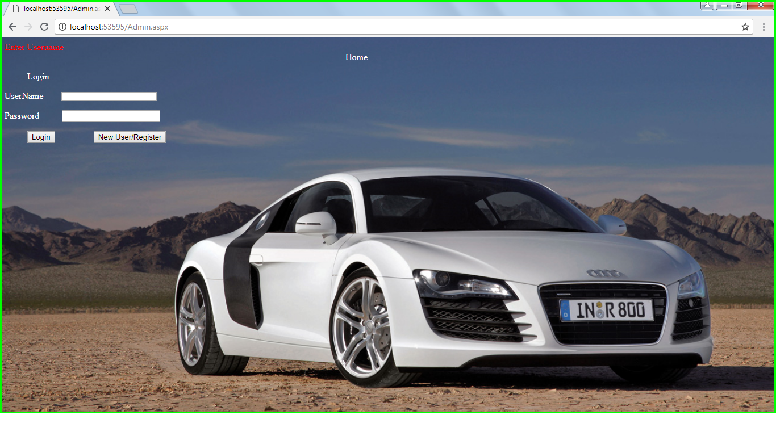
  2. **Enter Password**

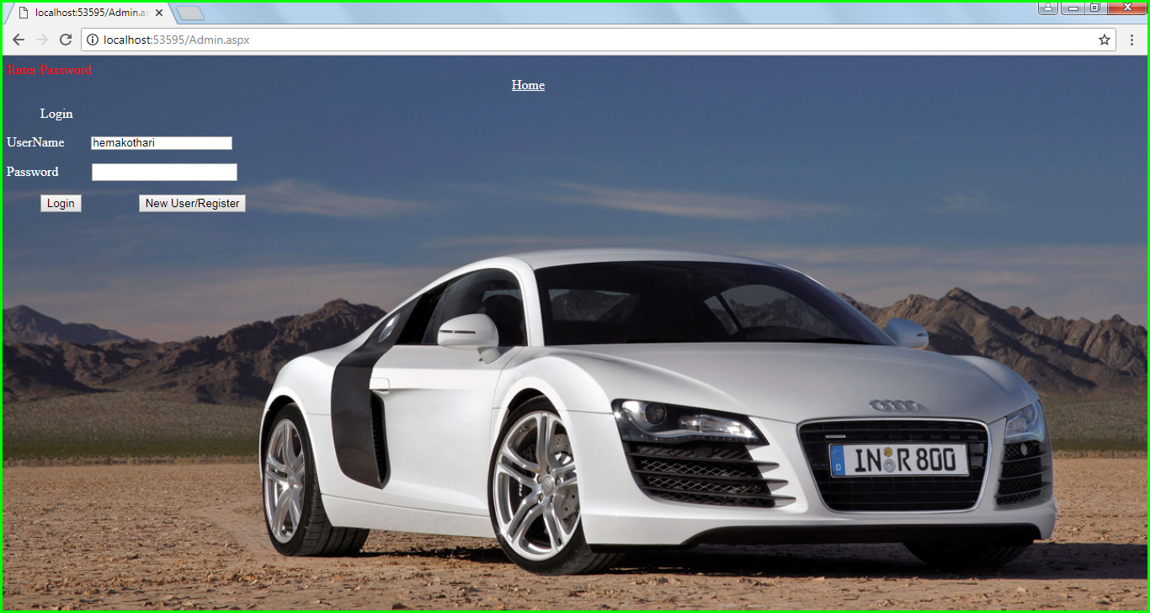

|  |  |
| --- | --- |
| **Test Case 2** | |
| **Test Case Name:** | On Login Screen, Invalid Credentials |
| **Description:** | If incorrect credentials entered, will show error message |
| **Output:** | Display validation Controller message in browser “Invalid Username and Password” |

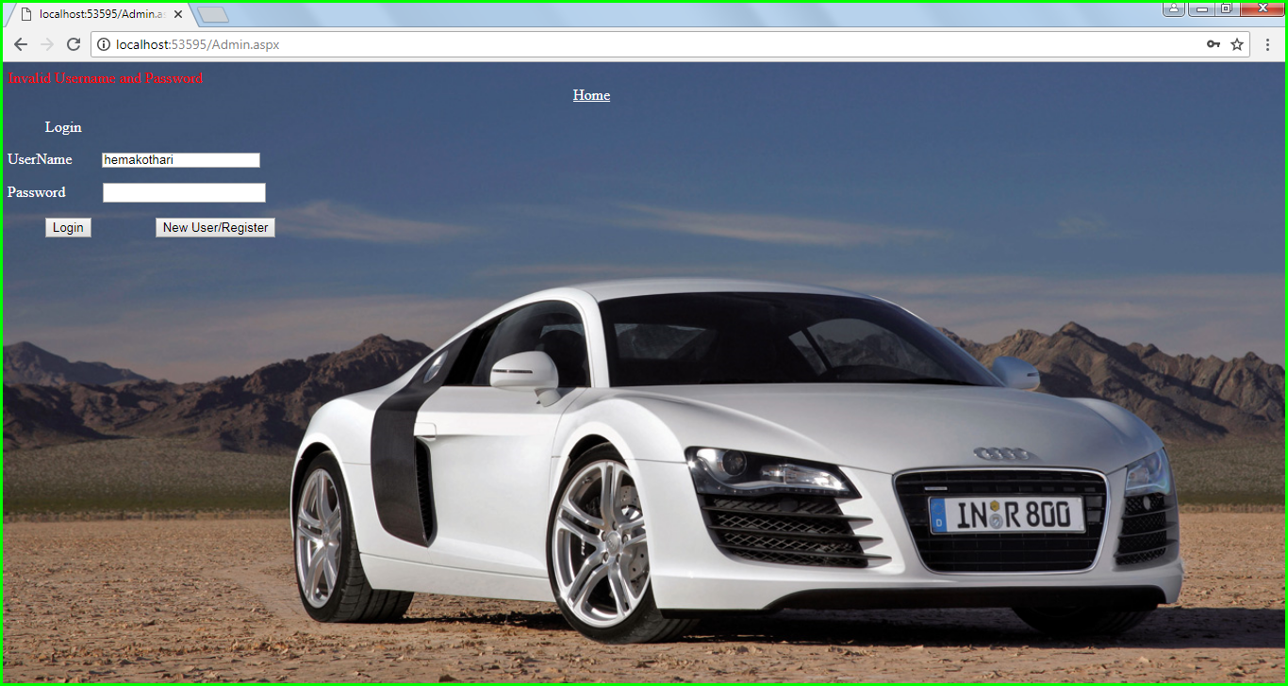

|  |  |
| --- | --- |
| **Test Case 3** | |
| **Test Case Name:** | On Add Vehicle Screen, Make/ Model/ Color/ Type/ Transmission Mode/ Price/ Capacity/ Location not entered |
| **Description:** | If Make/ Model/ Color/ Type/ Transmission Mode/ Price/ Capacity/ Location is not entered, will show error message. |
| **Output:** | Display validation Controller message in browser “Enter Make”  Display validation Controller message in browser “Enter Model”  Display validation Controller message in browser “Enter Color”  Display validation Controller message in browser “Enter Type”  Display validation Controller message in browser “Enter Transmission Mode”  Display validation Controller message in browser “Enter Price”  Display validation Controller message in browser “Enter Capacity”  Display validation Controller message in browser “Enter Location” |

* 1. **Enter Make**

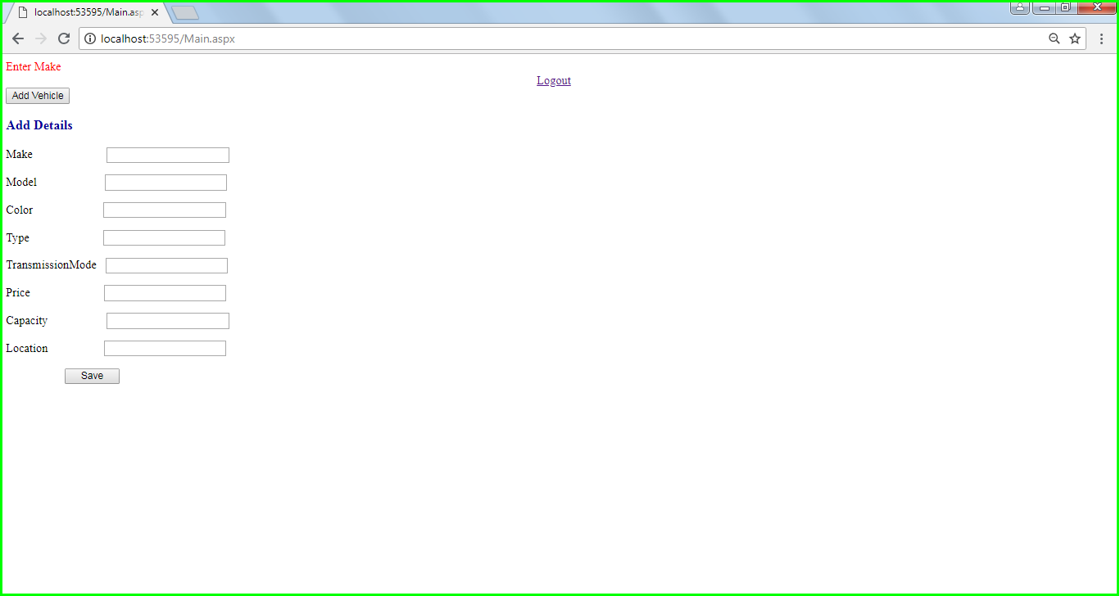

* 1. **Enter Model**

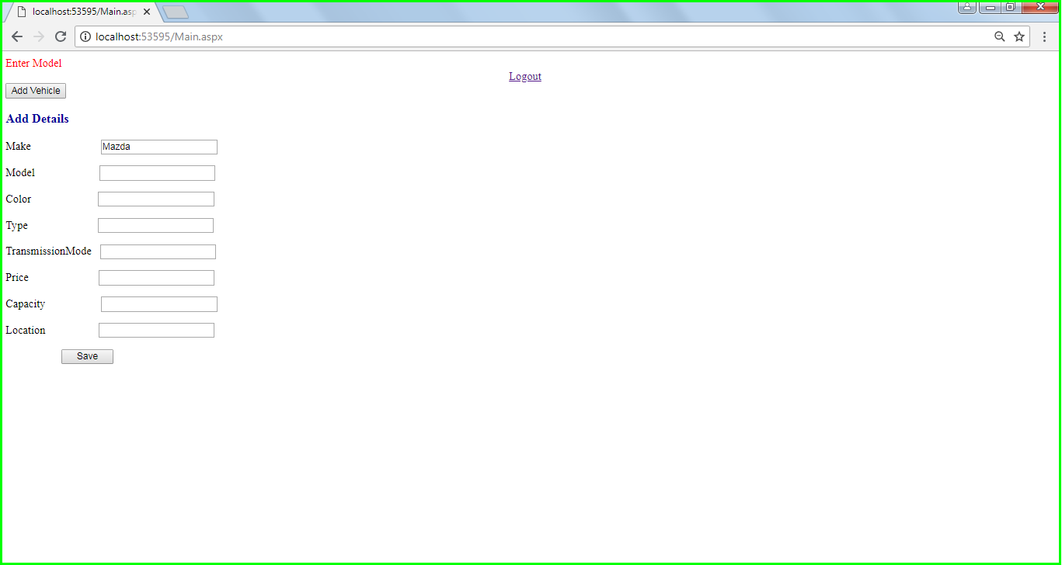

* 1. **Enter Color**

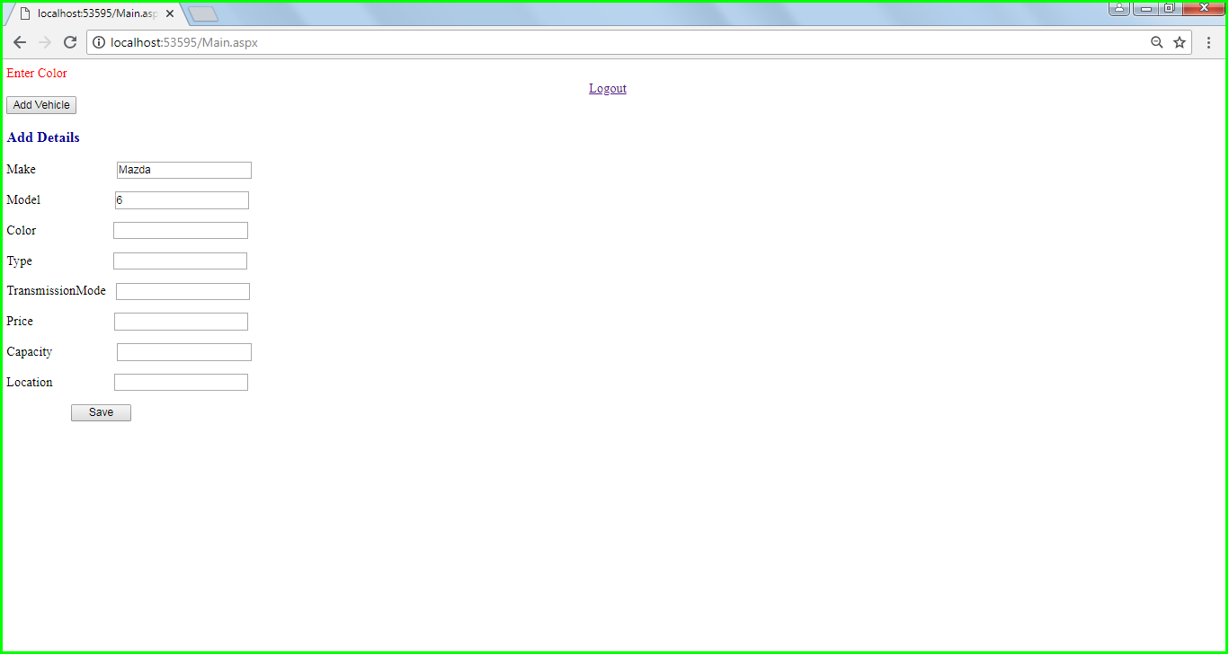

* 1. **Enter Type**

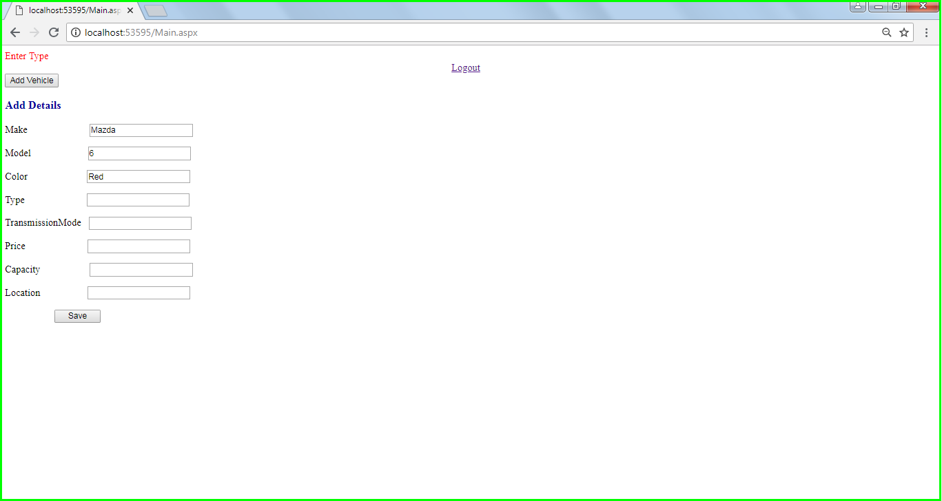

* 1. **Enter Transmission mode**

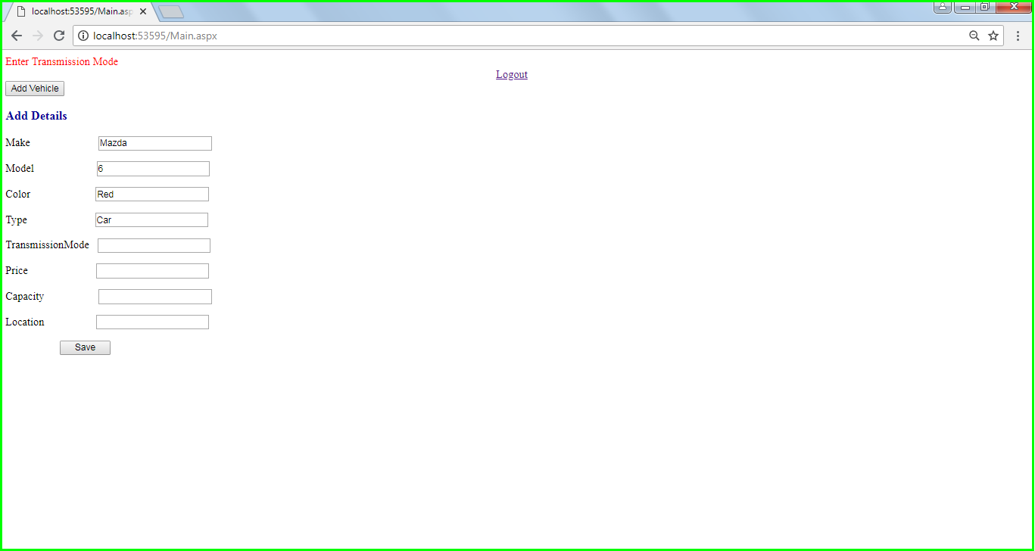

* 1. **Enter Price**

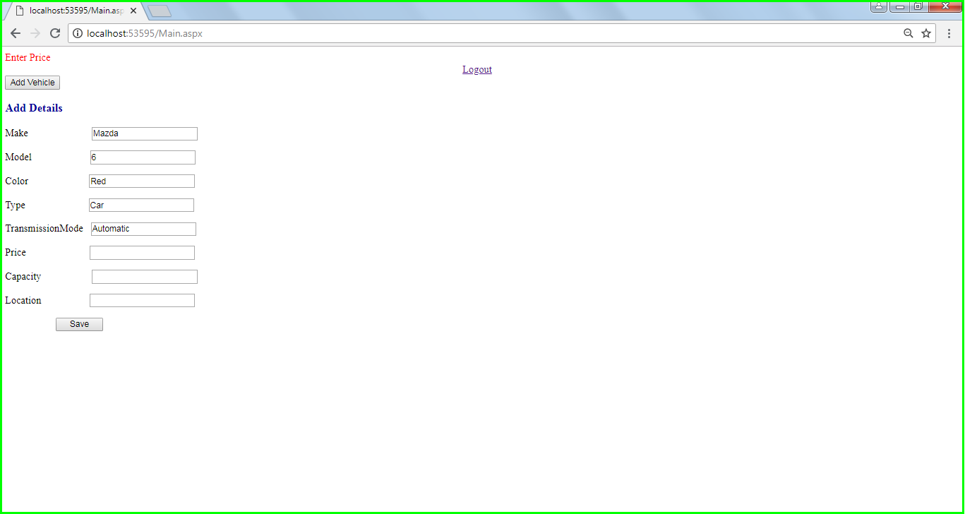

* 1. **Enter Capacity**

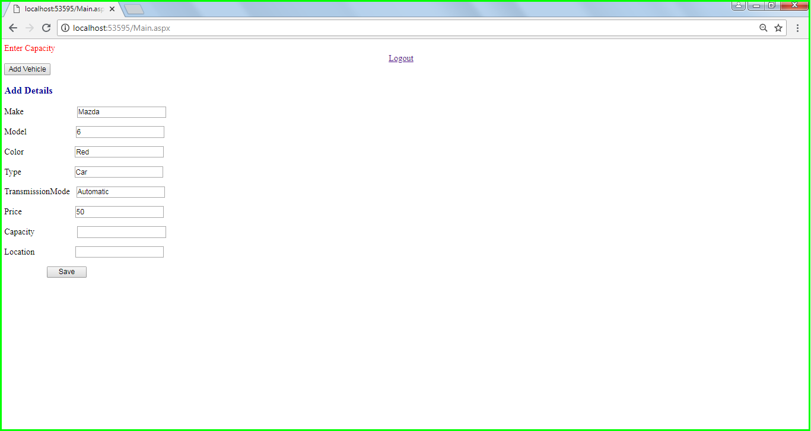

* 1. **Enter Location**

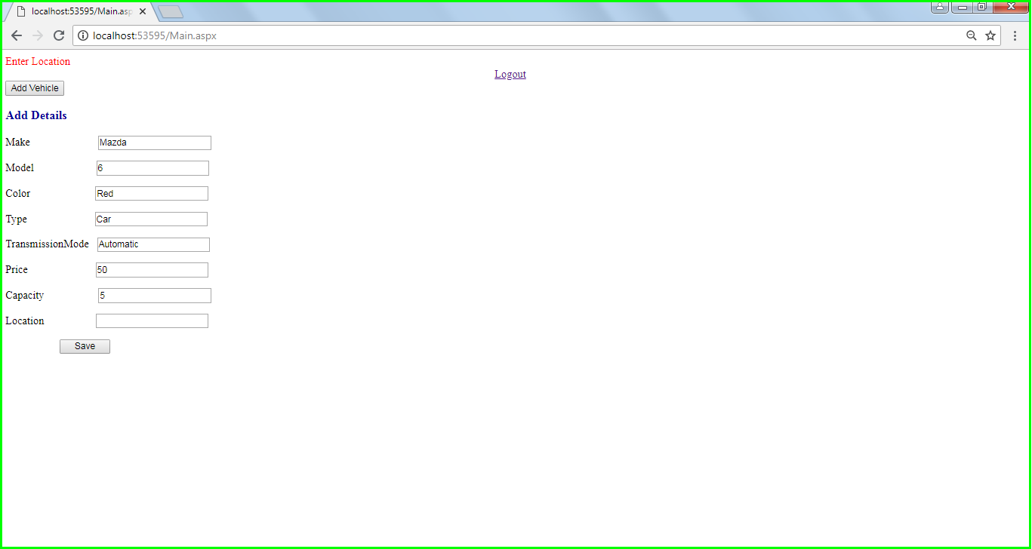

|  |  |
| --- | --- |
| **Test Case 4** | |
| **Test Case Name:** | On Register Screen, Username/ Password/ Confirm Password/ Name/ Phone/ Email/ DOB not entered |
| **Description:** | If Username/ Password/ Confirm Password/ Name/ Phone/ Email/ DOB is not entered, will show error message. |
| **Output:** | Display validation Controller message in browser “Enter Username”  Display validation Controller message in browser “Enter Password”  Display validation Controller message in browser “Enter Confirm Password”  Display validation Controller message in browser “Enter Name”  Display validation Controller message in browser “Enter Phone”  Display validation Controller message in browser “Enter Email”  Display validation Controller message in browser “Enter Date of Birth” |

* 1. **Enter Username**

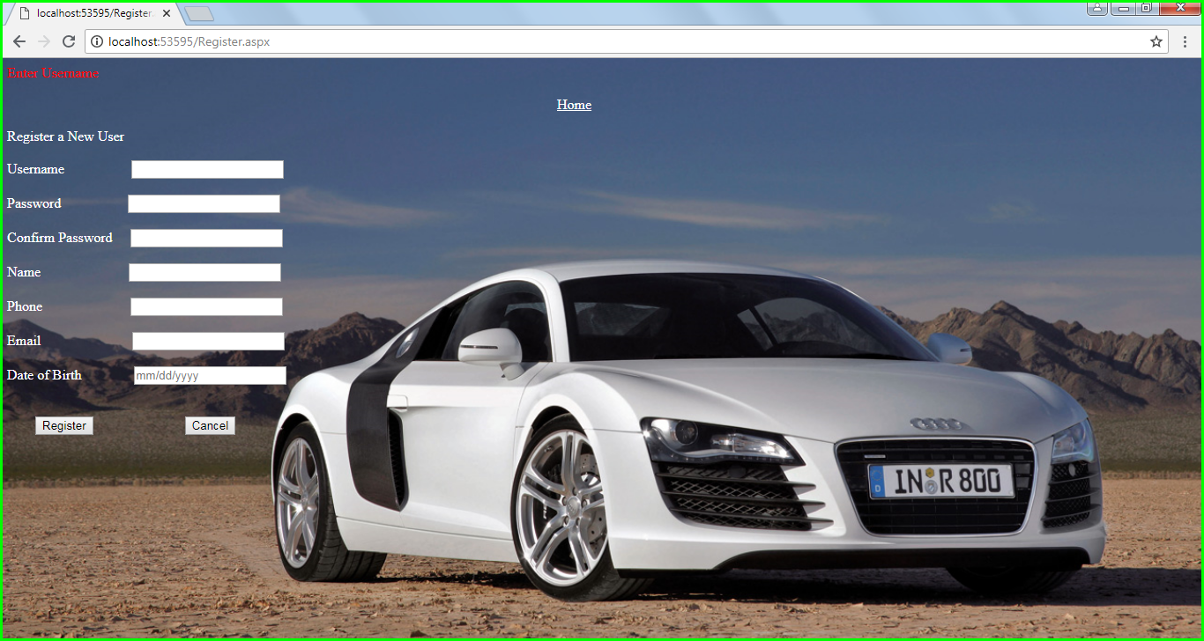

* 1. **Enter Password**

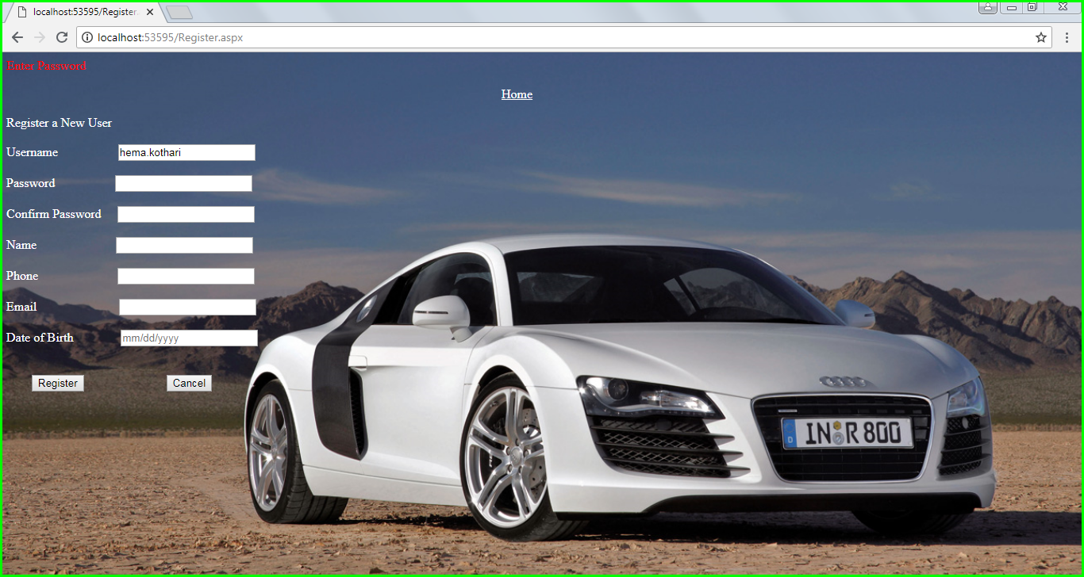

* 1. **Confirm Password**

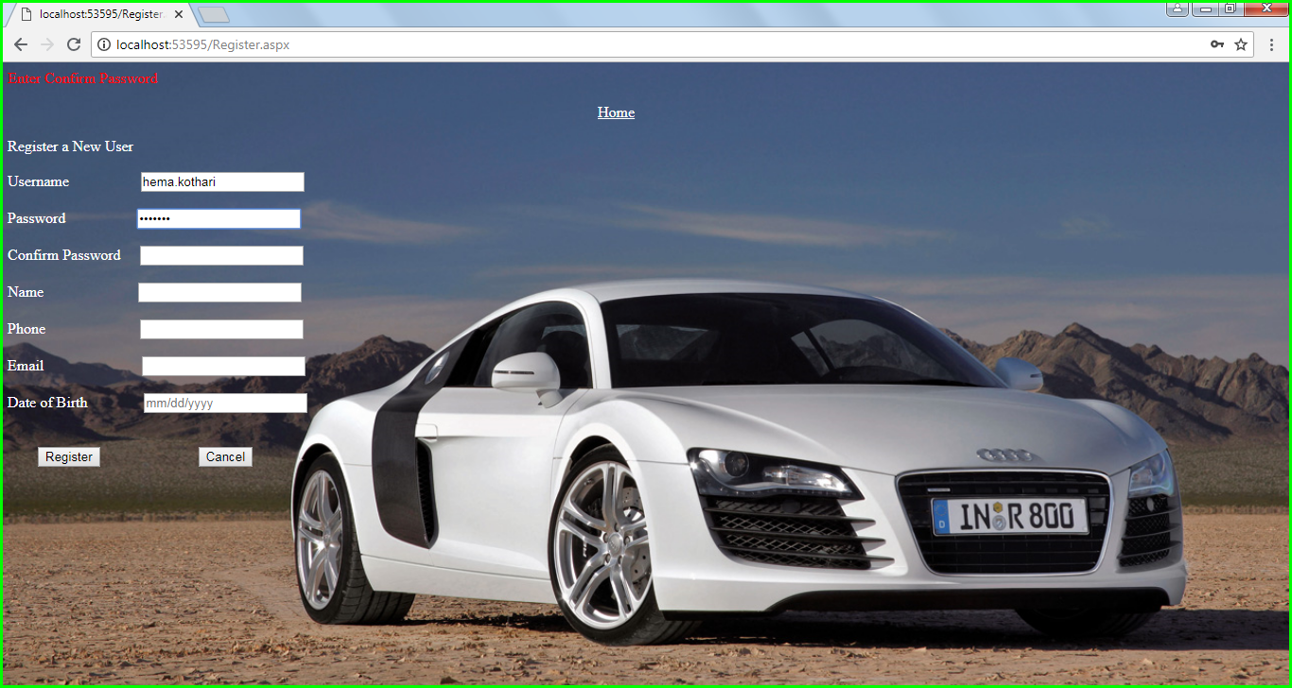

* 1. **Enter Name**

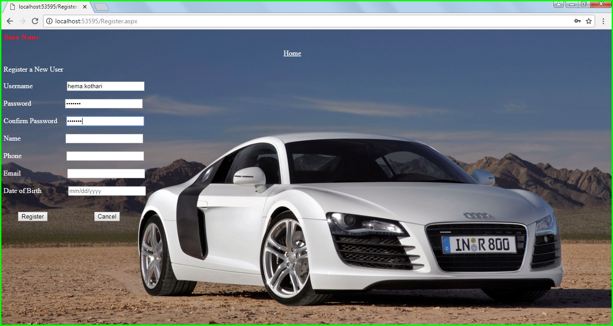

* 1. **Enter Phone**

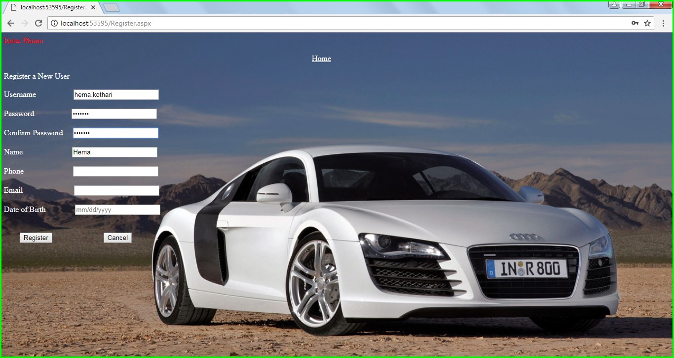

* 1. **Email**

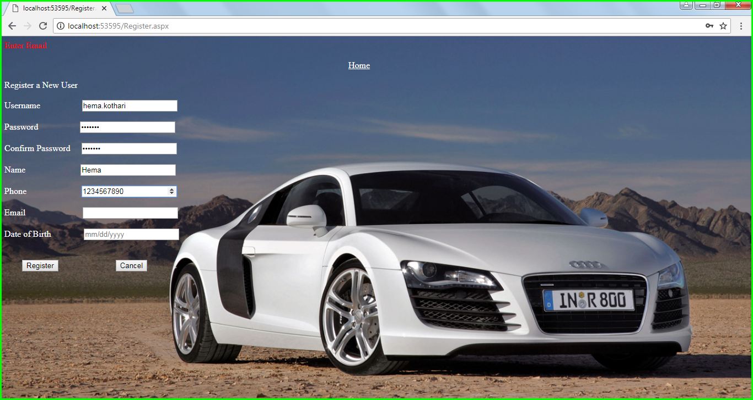

* 1. **Date of Birth**

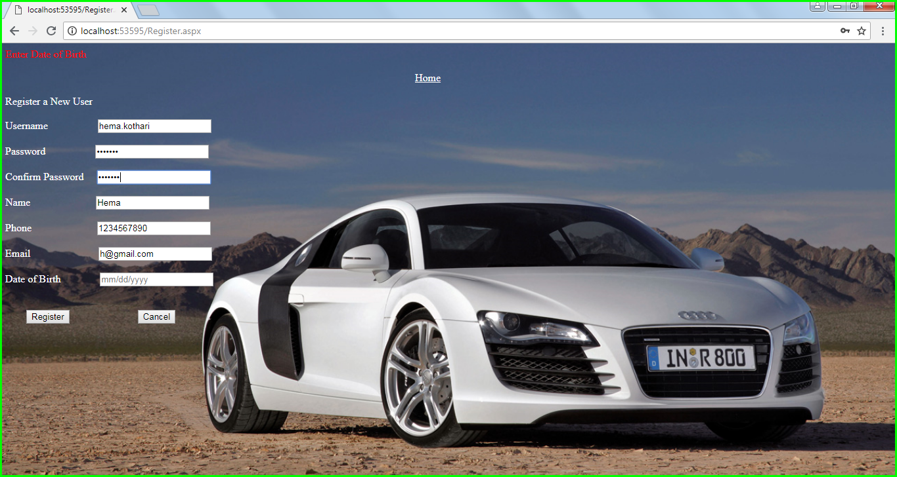

|  |  |
| --- | --- |
| **Test Case 5** | |
| **Test Case Name:** | On Register Screen, Password not same as Confirm Password |
| **Description:** | If Password entered is not same as Confirm Password, will show error message. |
| **Output:** | Display validation Controller message in browser “Password and Confirm Password does not match” |

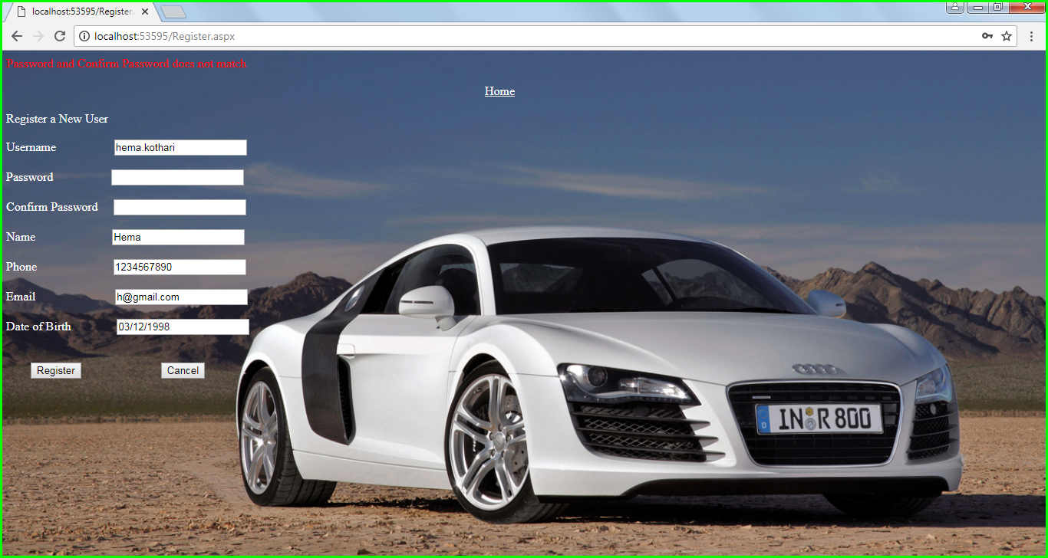

|  |  |
| --- | --- |
| **Test Case 6** | |
| **Test Case Name:** | On Register Screen, Incorrect Email Id Format |
| **Description:** | If Email ID entered is not in correct format, will show error message. |
| **Output:** | Correct format of Email Id to be entered is displayed |

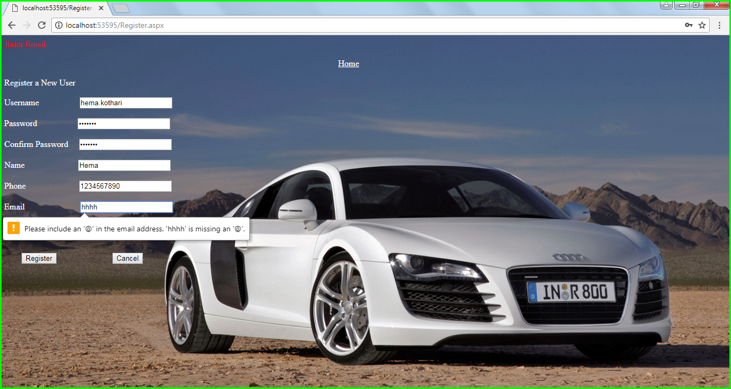

|  |  |
| --- | --- |
| **Test Case 7** | |
| **Test Case Name:** | On Home Screen, Location/ Date From/ Date To not entered |
| **Description:** | If Location / Date From / Date To is not entered, will show error message. |
| **Output:** | Display validation Controller message in browser “Enter Date From”  Display validation Controller message in browser “Enter Date To”  Display validation Controller message in browser “Enter Location” |

* 1. **Enter Date from**

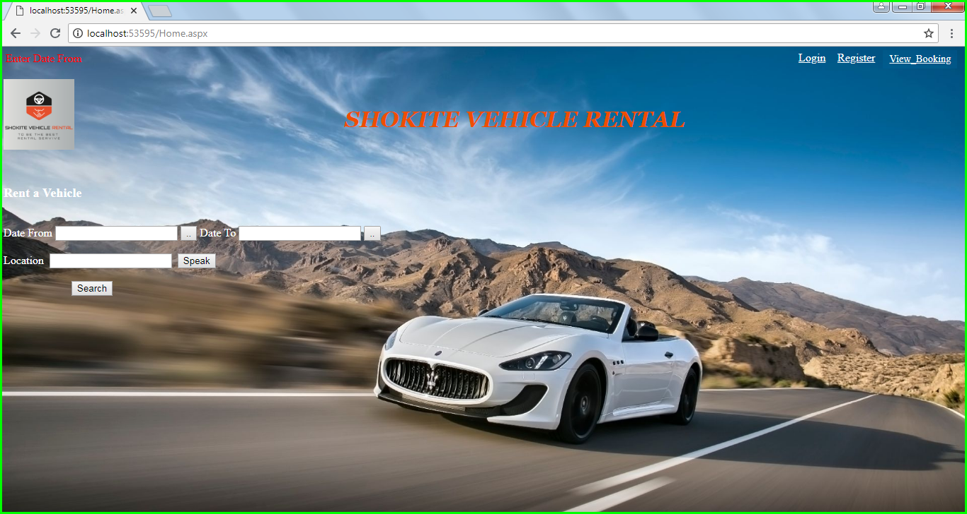

**7.2 Enter date to**

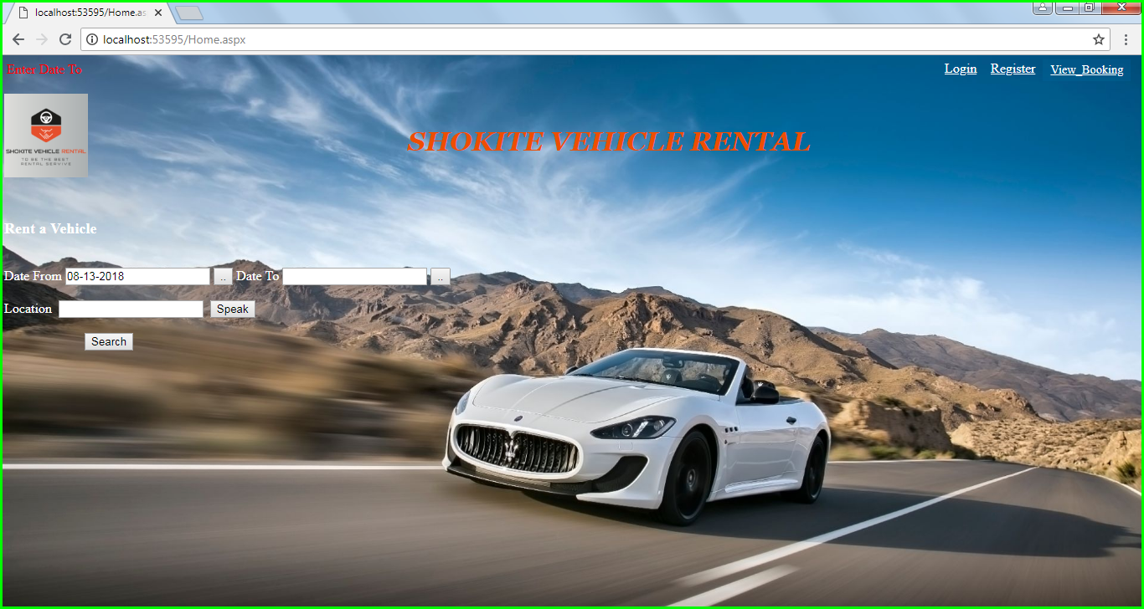

**7.3 Enter Location**

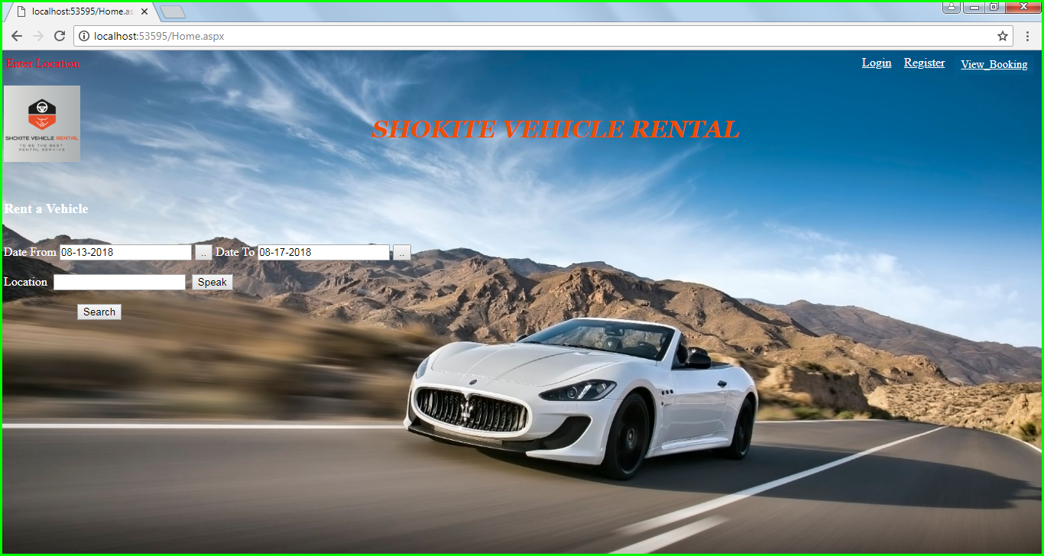

|  |  |
| --- | --- |
| **Test Case 8** | |
| **Test Case Name:** | On Payment Screen, Name/ Number/ Expiry Date/ CVV not entered |
| **Description:** | If Name/ Number/ Expiry Date/ CVV is not entered, will show error message. |
| **Output:** | Display validation Controller message in browser “Enter Name on Card”  Display validation Controller message in browser “Enter Card Number”  Display validation Controller message in browser “Enter Expiry Date”  Display validation Controller message in browser “Enter CVV” |

* 1. **Enter name on card**

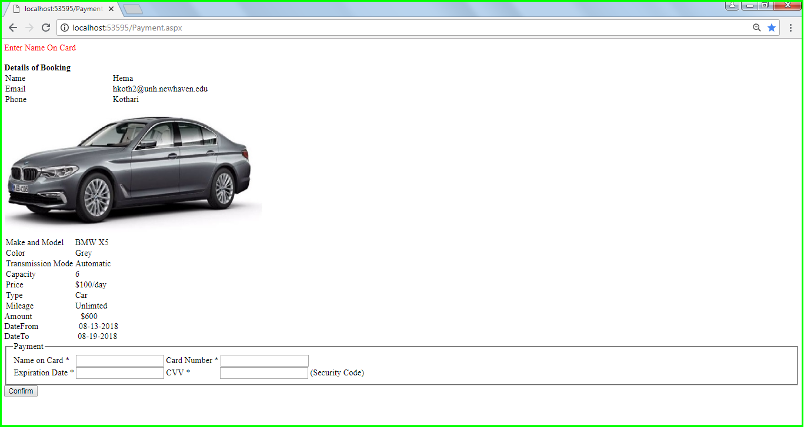

* 1. **Enter card number**

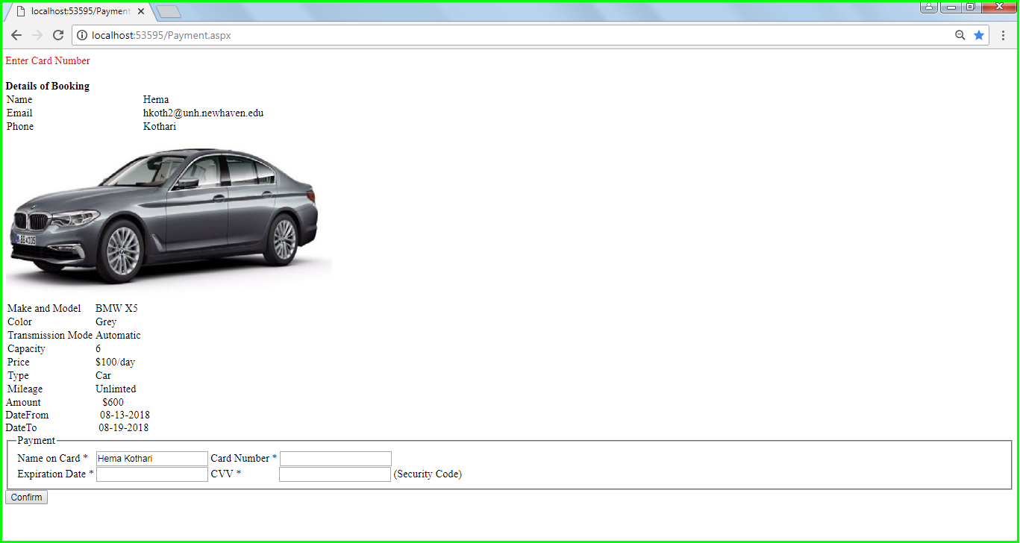

* 1. **Enter Expiration date**

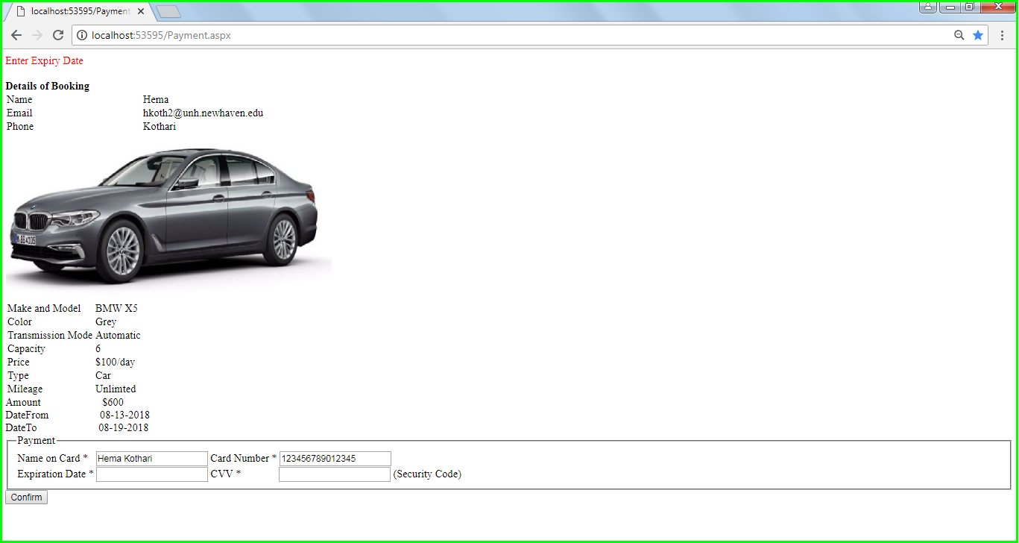

* 1. **Enter CVV**

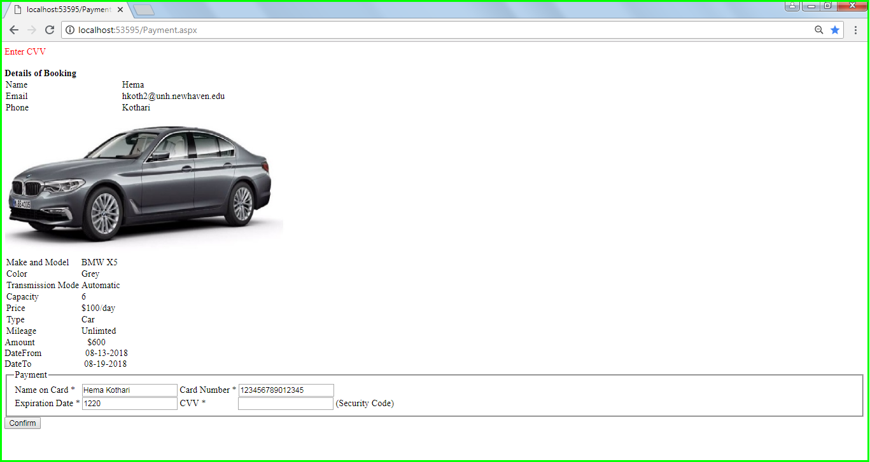

|  |  |
| --- | --- |
| **Test Case 9** | |
| **Test Case Name:** | On Continue as Guest Screen, Name/ Email/ Phone not entered |
| **Description:** | If Name/ Email/ Phone is not entered, will show error message. |
| **Output:** | Display validation Controller message in browser “Enter Name”  Display validation Controller message in browser “Enter Email”  Display validation Controller message in browser “Enter Phone” |

**9.1 Enter name**

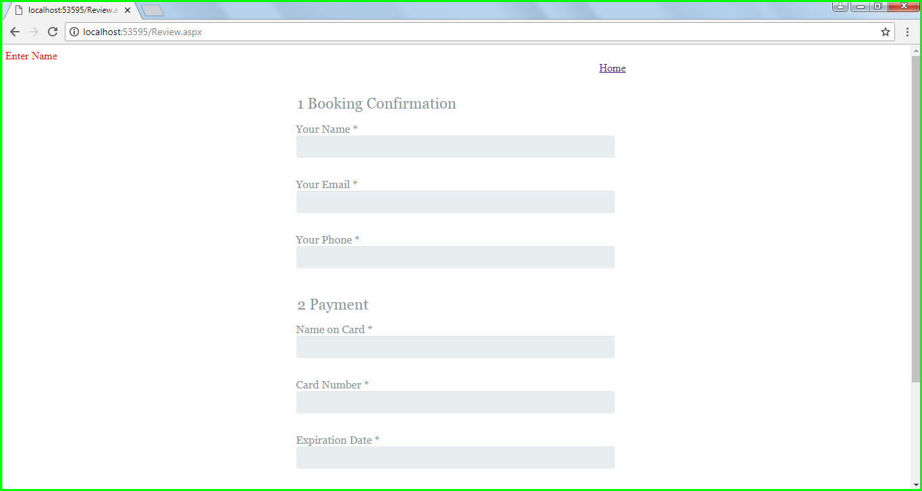

* 1. **Enter name on card**

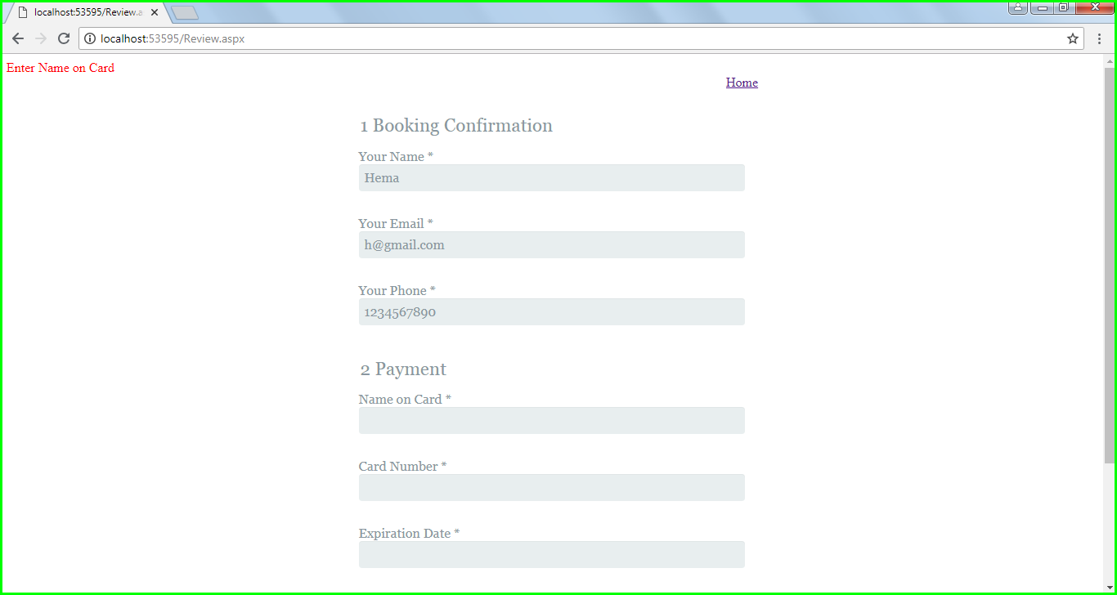

* 1. **Enter Email**

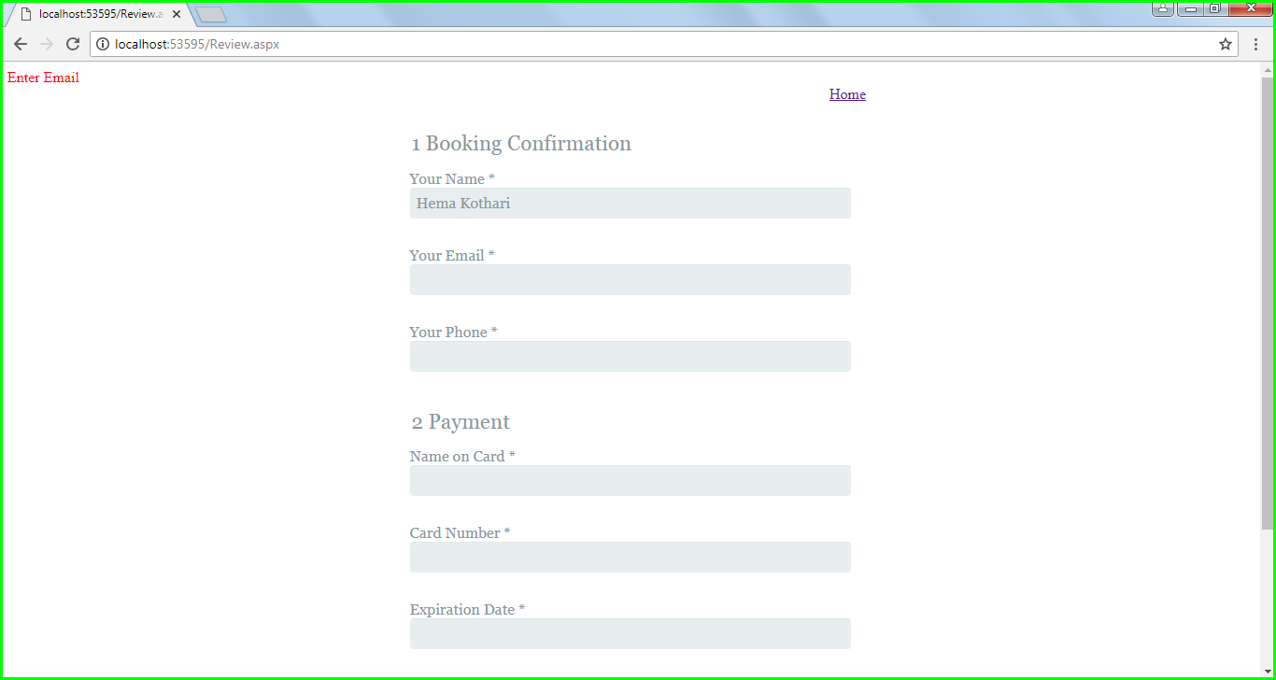

**9.4 Enter Phone**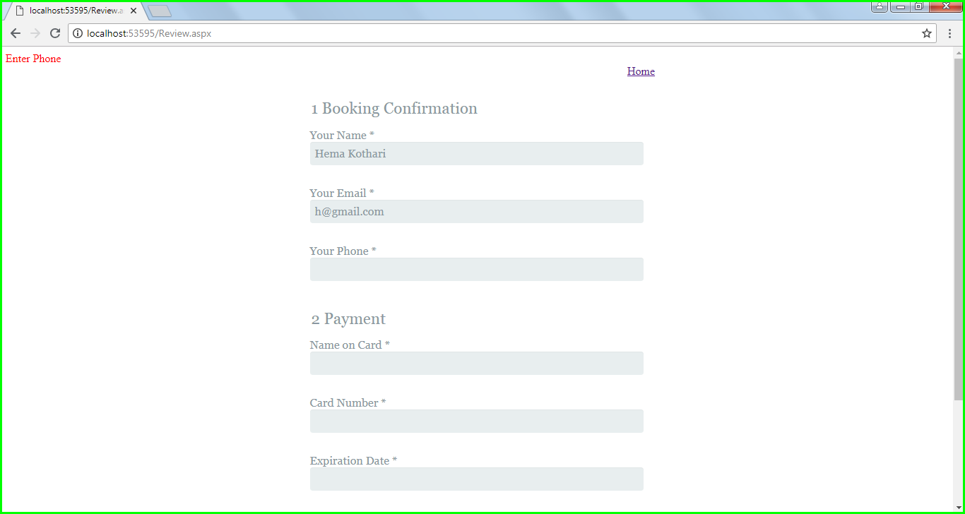

**9.6 Enter Name on card**



**9.7 Enter Card number**

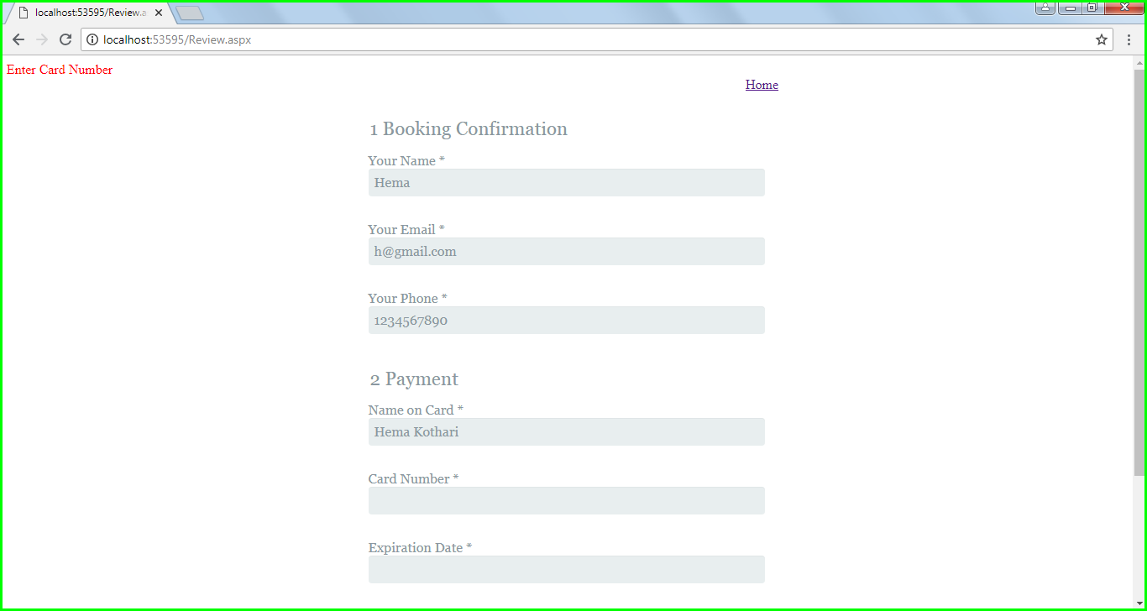

**9.8 Enter Expiration date**

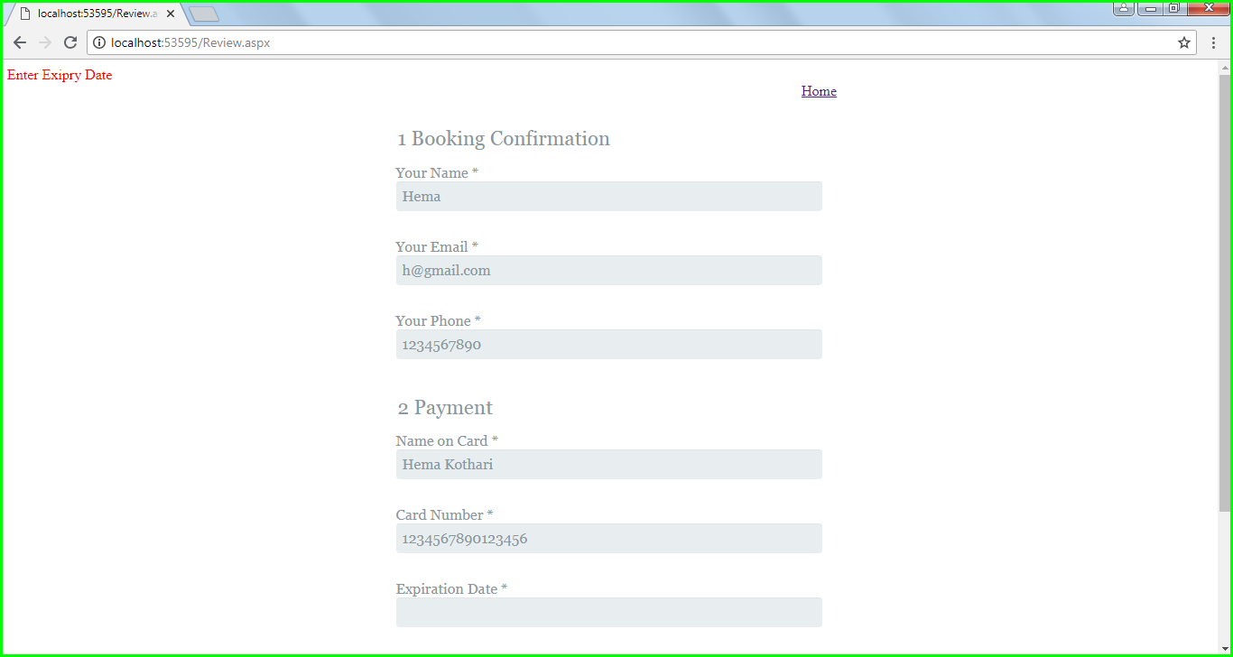

**9.9 Enter CVV**

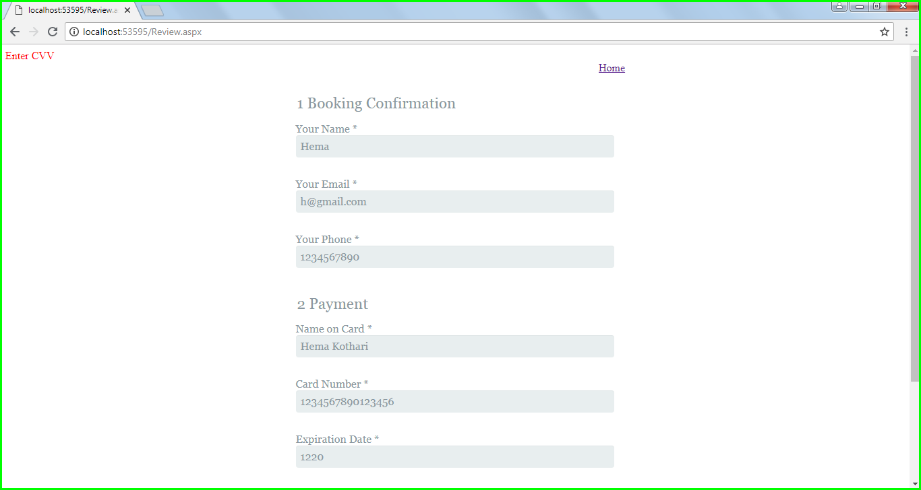

|  |  |
| --- | --- |
| **Test Case 10** | |
| **Test Case Name:** | On View Booking Screen, Booking Id not entered |
| **Description:** | If Booking Id is not entered, will show error message. |
| **Output:** | Display validation Controller message in browser “Enter Booking Id” |

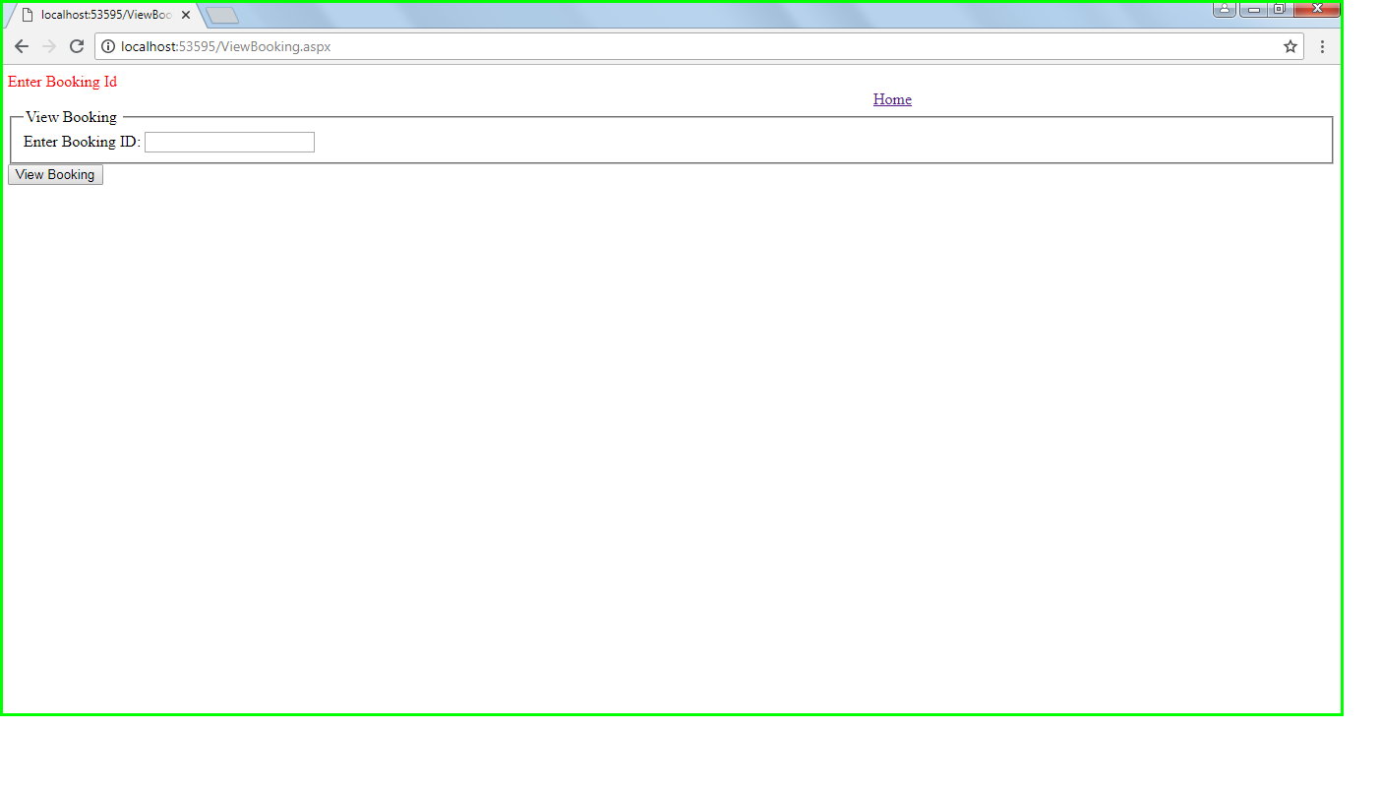

|  |  |
| --- | --- |
| **Test Case 11** | |
| **Test Case Name:** | On View Booking Screen, Invalid Booking Id entered |
| **Description:** | If Invalid Booking Id is entered, will show error message. |
| **Output:** | Display validation Controller message in browser “No Records Found” |

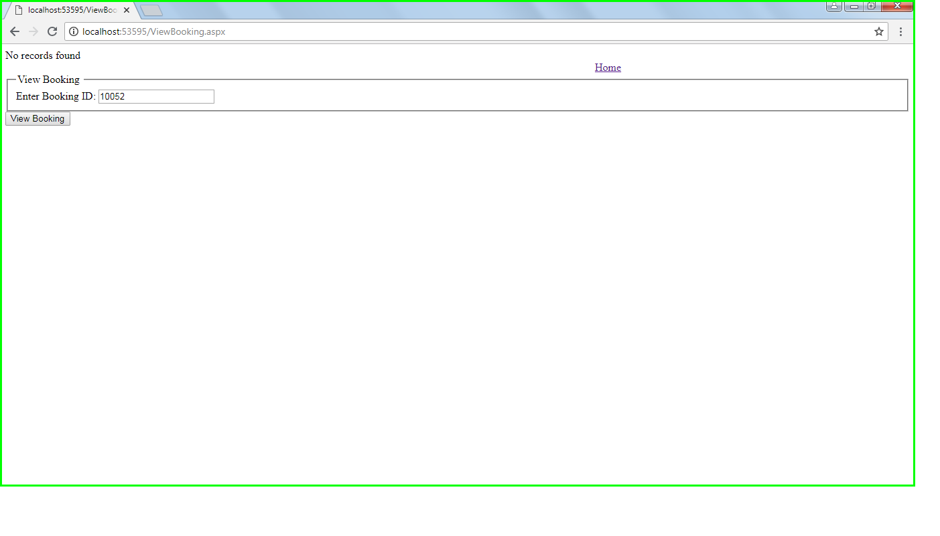

### 6.2.2 Console Output from Testing

Output is not being directed to console. Everything is on GUI

### 6.2.3 Screen Shots of GUI for Testing Plan

Screen shots of GUI added in 6.4.1 Section

### 6.2.4 Data File before and after the test showing changes

Data File before and after is added in 6.3 Section

# 7. REFLECTION

## 7.1 What worked well

* Co-ordination between project members was good.
* Work was distributed well, and no one was much overloaded.
* Task allocated were worked on defined timelines.
* Requirements were clear and we created good documentation.
* Able to do Voice Recognition which was not planned in this sprint
* Created a short video for better understanding/advertising of our system.

## 7.2 What didn’t work well

* Lot of time was spent in Research.
* Few priorities were misplaced.

## 7.3 Lessons learned

* Spent extended hours to cover research and rework time, so we must make sure that things are done straight at first place.
* Learned different types of diagrams and how project works in real world.
* Good understanding for Agile.
* Learnt about Bad Smell of programming but we were not able to implement it because of time constraints

## 7.4 Impact on project

* Because of Bad Smell the Code is very long.

# 8. APPENDICES

## 8.1 Use cases for the next Phase

Please Refer use cases below for next phase

* + 1. Filter on Average Customer Rating
    2. Vehicle Pick-up Locations
    3. Drop Vehicle at Home
    4. Receipt of booked Vehicle
    5. Adding Additional Drivers with insurance
    6. Printing receipt of booked vehicle
    7. Upgrade an existing booking
    8. Assign privileges to Customer
    9. Modify future booking
    10. Cancel future booking
    11. Provide Insurance details
    12. View Terms and Conditions
    13. Choose a language
    14. Rent a vehicle for long term
    15. View reward points
    16. Rate and Review
    17. Choose Additional Accessories
    18. Pick up and Drop off Location
    19. Access to Reports
    20. View Special Rates
    21. Manage Memberships
    22. Access to Driving Records
    23. Redeem Reward Points
    24. Navigate Pick Up Location
    25. Access to customer benefits
    26. Provide Promotions, Membership rewards points, Family benefits
    27. Administrator Should Provide Proper Encryption
    28. Choose calendar day
    29. Customize Payments
    30. Payment through PayPal

## 8.2 Tools Used

* + 1. Software used for this system - ASP.Net, SQL Server, Visual Studio
    2. Software used to produce your documentation – Microsoft Word and PowerPoint
    3. Any other technology used to build this system - <https://www.draw.io/>

# QUALITY ATTRIBUTES

## Runtime Qualities

|  |  |  |  |
| --- | --- | --- | --- |
| Attribute[1] | Bus  Rank[2] | Design Align[3] | Run Time Quality Attribute Documents[4] |
| Performance | 1 | Meets | The User Interface loading time is within seconds.  The data updating, and insertion is very fast. Search time for vehicle is within minutes and accordingly the customer can view or book the vehicle |
| Reason for Business Rank <> 1: The entire system is based on the performance |
| Explanation of Design Alignment <> Meets: Process is being executed correctly as per our expectations when we test all the modules |
| Reliability | 2 | Meets | Our Rental system operates appropriately for search and booking of the vehicle. Includes consistent stability of the system during available hours. We also have reliable database for storing data. |
| Reason for Business Rank <> 2: Our System is trustworthy meeting customer satisfaction with accurate results |
| Explanation of Design Alignment <> Meets: The flow of data is as expected |
| Scalability | 3 | Meet | System is capable to continue to function well when it is changed in size or volume in order to meet the customer requirement |
| Reason for Business Rank <> 3: Our system scales well and will be able to maintain or even increase its level of performance or efficiency when tested by larger operational demands. |
| Explanation of Design Alignment <> Meets: Our system is scalable on small as well as large set of data. |
| Security | 2 | Meets | We have username and password authentication where the system blocks the customers for invalid attempts. We will include password encryption in future. |
| Reason for Business Rank <> 2: Should check whether the customer credentials are correct. |
| Explanation of Design Alignment <> Meets: Invalid attempts block the customers. |
| Availability | 2 | Meets | Our system is online and will be available all the time except for the maintenance window which will be usually every month end. |
| Reason for Business Rank <> 2: During maintenance, the system is not available for booking. |
| Explanation of Design Alignment <> Meets: Services can be used when application is available |
| Supportability | 4 | Does Not Meet | In future we will be implementing a 24/7 customer support for any queries. |
| Reason for Business Rank <> 4: Will be implemented in future |
| Explanation of Design Alignment <> Does not Meets:  Customer service will be available all the time. |
| Traceability | 1 | Meets | All the data is stored in a secured Microsoft SQL Server database and admin has access for data. Admin assigns privileges to view and perform different activities. |
| Reason for Business Rank <> 1: The data is secured and is accessible when needed. |
| Explanation of Design Alignment <> Meets: Response is displayed on webpage |
| User Usability | 2 | Meets | Our system is user friendly which helps in successfully completing a task. Includes clear, concise navigation, terminology, and error messaging. |
| Reason for Business Rank <> 2: 95% of users need not read the user guide to be able to use the website. |
| Explanation of Design Alignment <> Meets: Our Website can easily understandable and can be operated by anyone |

## 9.2 Development Qualities

|  |  |  |  |
| --- | --- | --- | --- |
| Attribute[5] | Bus Rank[6] | Design Align[7] | Development Quality Attribute Documents[8] |
| Reusability | 3 | Meets | There are generalized functions, where a part of the code can be used by any part of the software or program. |
| Reason for Business Rank <> 3: Reusable code |
| Explanation of Design Alignment <> Meets: Design is precise and can be converted |
| Extensibility | 1 | Meets | Entire system works on a generalized database. The system can be extended accordingly without making any changes in its functional architecture. For example, in future we will also provide vehicle search service based on VIN. |
| Reason for Business Rank <> 1: Adding doesn’t change the system architecture |
| Explanation of Design Alignment <> Meets: The configurations are not disturbed |
| Modifiability | 2 | Meets | Adding additional functionality or extending the scope of the system doesn’t affect existing code or reliability of the system. |
| Reason for Business Rank <> 2: Adding or extending changes doesn’t affect the system |
| Explanation of Design Alignment <> Meets: Adding a module is being executed correctly |
| Ease of Integration | 3 | Meets | There is no change in database and the basic state of code. If we implement billing or any other system integration, the core of the code remains same. |
| Reason for Business Rank <> 3: Ease of integrating with other systems without affecting code. |
| Explanation of Design Alignment <> Meets: Integrating with another system is easy |
| Phase-In “ability”  *(Subset-ability)* | 2 | Meets | The code is bonded with designs in such a way that .NET has coding and designing files separately but are extended with each other. |
| Reason for Business Rank <> 2: Files are secured |
| Explanation of Design Alignment <> Meets: The coding styles are secured and not easily affected |
| Conceptual Integrity | 1 | Meets | According to the design of project, the architecture is user-friendly, clear and concise. |
| Reason for Business Rank <> 1: Easily understandable |
| Explanation of Design Alignment <> Meets: Designed in such a way that even a non-IT person can understand |
| Testability | 1 | Meets | The software is tested under general environment according to the resources available. |
| Reason for Business Rank <> 1: Main part of the entire system development process |
| Explanation of Design Alignment <> Meets: All the test cases are satisfied |
| Portability | 1 | Meets | Our Application could be operated majorly on all operating systems. The website is responsive so it supports for small and big aspect ratios without disturbing the user interface |
| Reason for Business Rank <> 1: Anyone can operate on their PC or mobile browsers. |
| Explanation of Design Alignment <> Meets: Worked on different PCs with different configuration |
| Developer Complexity | 2 | Meets | The design and the coding are bonded and maintained in separate files. The database is structured in such a way that the reference can be easily found and understandable. |
| Reason for Business Rank <> 2: Database contains all the information where few are to be secured |
| Explanation of Design Alignment <> Meets: Files are independent. So if one file is affected there will be no problem for other files |
| Buildability | 1 | Meets | The software would need Microsoft Supportable Platform which could deploy ASP .NET code as well as Microsoft SQL server databases with the framework of 4.5 or higher. |
| Reason for Business Rank <> 1: Works in real time if hosted |
| Explanation of Design Alignment <> Meets: The execution took place without any major errors |

# REFERENCES

* Documents on Blackboard as below:
* Presentation on different topics
* Other word documents
* Quality Attributes document.

1. Quality attributes are a useful means for analyzing architectural designs
2. Working with a business resource, rank each quality from 1-5 with 1 being the most important. As a guideline, start with 3 as the default, then move up or down based upon investment/priority of the item. If it is expected to invest more time/money, then the rating should be increased. If it is less important and it would be desirable to spend less time/money, then it should be decreased. Time/Money could reflect development or runtime impacts. For example, it might imply that a change in service tier is desirable.
3. Design alignment. Identify whether or not the design meets requirements and importance of a given quality attribute. (Does Not Meet, Meets, Exceeds)
4. Explain any increases/decreases in business rank as well as any places where the design is not in alignment with the rank.
5. Quality attributes are a useful means for analyzing architectural designs
6. Working with a business resource, rank each quality from 1-5 with 1 being the most important. As a guideline, start with 3 as the default, then move up or down based upon investment/priority of the item. If it is expected to invest more time/money, then the rating should be increased. If it is less important and it would be desirable to spend less time/money, then it should be decreased. Time/Money could reflect development or runtime impacts. For example, it might imply that a change in service tier is desirable.
7. Design alignment. Identify whether or not the design meets requirements and importance of a given quality attribute. (Does Not Meet, Meets, Exceeds)
8. Explain any increases/decreases in business rank as well as any places where the design is not in alignment with the rank.